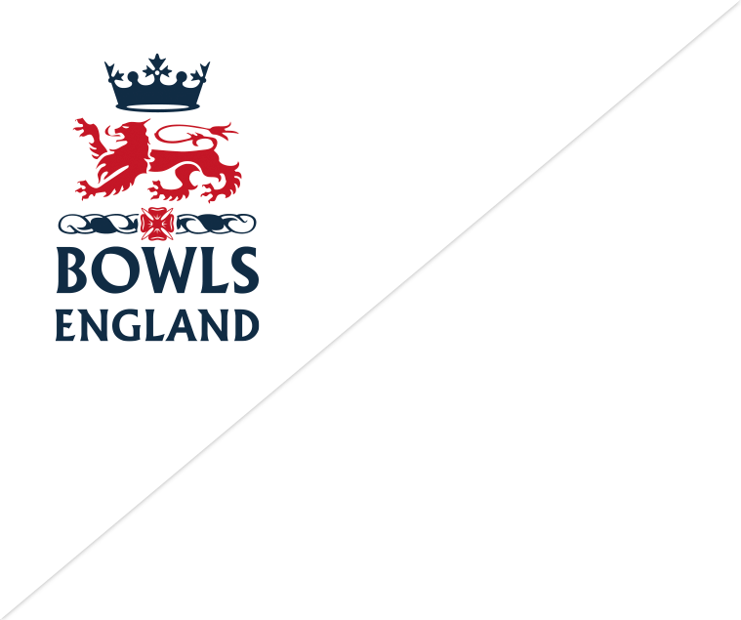

Membership Register
Bowls England members, through their County Associations, asked for one centrally led Membership Register. This has been introduced to give us the opportunity to improve our services to members, clubs and county associations in the future.
In the future the Membership Register software will give clubs the opportunity to fully manage and communicate with their members, using a free of charge, secure online platform.
Members will have the opportunity to receive all of the latest news, updates and offers directly from Bowls England.
The information this will provide nationally will give our sport a much greater opportunity to secure future government and commercial funding that can be used to support clubs at grassroots level.

