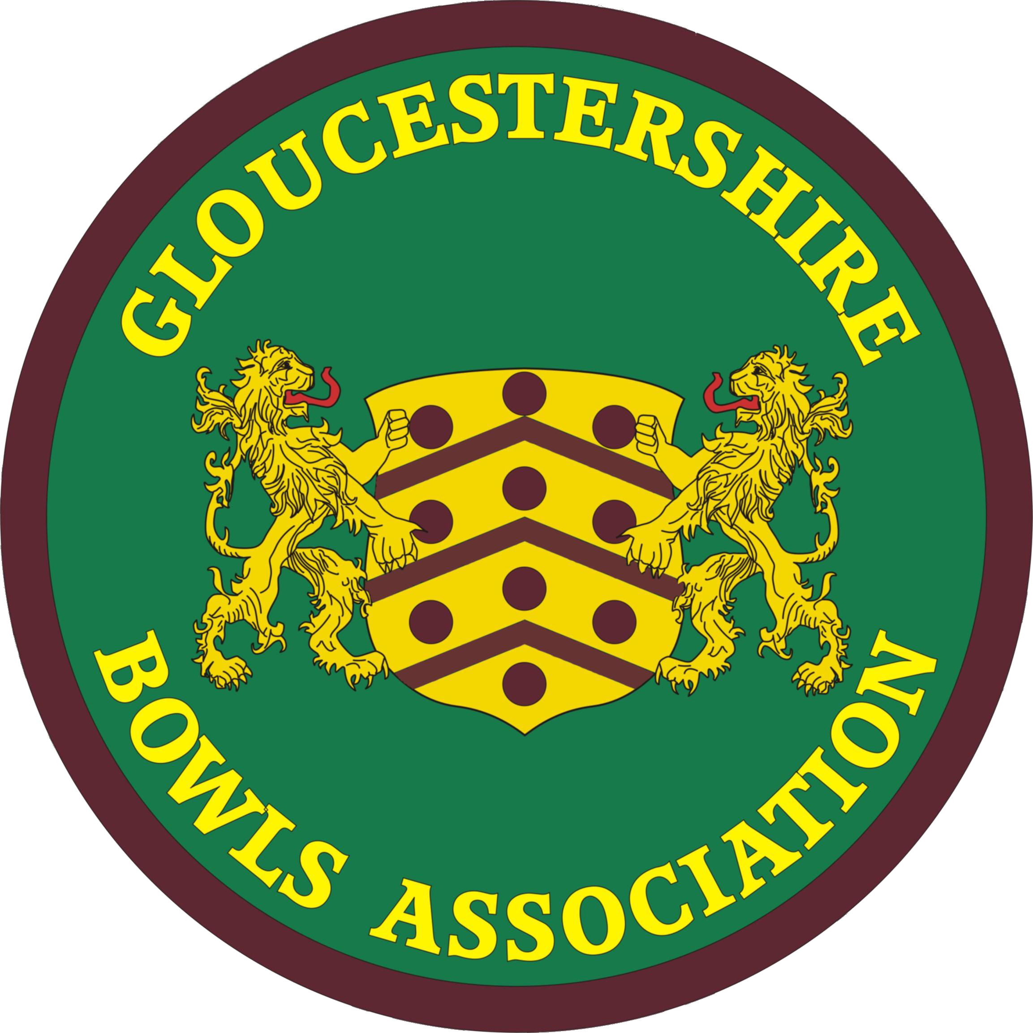 | GLOUCESTERSHIRE BOWLS ASSOCIATION  A Member of Bowls England.
G.B.A Women’s Division Annual Delegate Meeting
Whitminster Village Hall

Wednesday 25 October 2023, 1.30 p.m.

Minutes

The President opened the meeting by welcoming delegates. She referred to members who had passed away in the last year, for whom a minute’s silence was observed :

Joan Surman (Cheltenham)
Lin Howell (Begbrooke Green)
Mary Wetmore (Yate)
Kath Sealey (Bristol Greenbank)
Marie Smith (Frampton on Severn)

- Apologies 36 clubs sent representatives and 3 clubs sent apologies. 14 officers and officials were in attendance. Details in records.

- Amendments to minutes of meeting 22.3.23 None

- Ratification of minutes dated 22.3.23 . Ratified, and signed by President

- Matters arising

  - County Benevolent Triples (LC) Much enjoyed. Excellent entry. Winners Chris Prosser, Jackie Phelpstead and Gill Fry. Runners up Val Molton, Sue Osborne and Sue-Ellen Baker. Well done to them all !! Plate Winners : Wendy Campbell, Veronica Baldwin and Stella Webster. I’d like - in this context - to minute the Association’s and the Women’s Division’s thanks to Gloucester Spa and Gloucester City for their ongoing support for this and other County activities.

- Welcome and message from President

“Good afternoon ladies. It is unbelievable that another year has passed. Once again it has been a pleasure to be your President and a Gloucester Selector (though the latter was unofficial) and I’m hoping that both can continue into a third year.
Attending all the County games either watching or playing has been a delight. Seeing new County players having their first games and being so enthusiastic is excellent for the future of Gloucestershire County Ladies, going forward.
We have had success this year : Playing Warwickshire in the 1st Round of the John’s Trophy at Fairford and winning it convincingly. Then we played Devon at Clevedon, where the weather was atrocious and the green was very challenging. Unfortunately, we were unsuccessful at this point. However, we should be encouraged for next year.
The Selection Committee and the John’s Squad did not manage to have a full debrief or a ‘move forward meeting’ after the games. When the Committee called the meeting (as is normal every year), the attendance was extremely low, for whatever reasons. With this in mind, the Selection Committee and the Team Manager will hold a ‘move forward meeting’ before the start of next season, when I hope that the attendance will be higher. The date will be confirmed in the New Year.
As well as the John’s, Walker and Amy Rose, Gloucestershire Ladies played in the Middle England League, which I’m so pleased to share with you all that we won this year. It has been a few years since we had this success; I believe our last time was our first year after joining the League. Thanks you to all the bowlers who played in the MEL – a fantastic result. On behalf of County, I’m privileged to have been invited to pick up our award at the MEL meeting in November.
Obviously, we cannot forget the wonderful achievements of all the bowlers who qualified for the Nationals at Leamington.
Finally, I’d like to say thanks to everyone who works so hard for the County all year – Selection, Competitions, Finance, Fixtures, Administration – these are our ‘unsung heroes’ and without them giving so much time, the County would not be so well run. Thanks also to the clubs who make their greens available for County games, plus Semi-Final and Finals days.
I wish you all a very happy and healthy Winter and look forward to seeing you again next year.”

- Secretary’s Report Lindsay Collin

  - Lots going on at the County level, so still plenty of stress. But inevitably less in some respects from the Divisional side, with the Divisional structure of the GBA ending after the 2024 season and my own role in the Women’s Division thus having just one year to run.

Some quick points to initially note :

    - Affiliation. As an Association, we increased our membership during the last 12 months by 2.0 %. However, the better news is that our known membership gains during the 2023 season were 6.6% (7.2% women, 6.3% men), showing how effective the gains made due to recruitment and coaching have been, often related to the Bowls England schemes, but obviously offset by losses over the 2022/3 Winter. Dismayed that 24 out of the now 55 clubs in the Association (City & Port of Bristol BC closed last month) did not admit to having any new members at all during the complete season. The 2024 Affiliation will again be in May.
    - 2024 GBA Club Data Form – information for the 2022 Club Handbook. Will go out in early November, to give us club information to reside on the online Gloucestershire Computer Management System (more of this later on). Postal Addresses of club officers will be no longer be sought.
    - 2023 GBA WD Club Information Form – usual information from clubs about their competition winners in the 2023 season, young bowlers and players for the Women’s County List. Also to go out in early November.
    - The GBA Joint Council Meeting (JCM) will be on Saturday 11 November 2023 (see earlier notice re change of date from 19 November) and the GBA AGM will be on Saturday 20 January 2024. These will both be at Whitminster Village Hall. Information will be circulated in the coming two weeks on the JCM discussion topics. Will probably include :
- Update on Structural and Constitutional Review process. Board roles and appointment.
- Update on Computerised Management System. Bob Berry (Frampton on Severn) appointed as System Administrator.
- New GBA Website. Steven Wharram (Olveston) appointed as Website Manger.
- GDPR implications of the Management System in relation to GBA GDPR Policy and Club GDPR policies.
- Safeguarding becoming mandatory for the Association and for clubs (see discussion on March 2023 WD Delegate Meeting minutes).
- Club Registration with Bowls England – the latest situation.
I wouldn’t really propose to say too much more about any of these, as the JCM is only a little over two weeks away now.
    - Annual Luncheon & Presentations Annual Presentation Luncheon at Hatherley Manor, held three days ago. Luncheon attendance again higher than ever. People seemed to enjoy it overall and the majority thought the food to be very good this year, but – with so many to satisfy – not everyone will have had the same experience. Congratulations of course, to all those who walked away with a trophy and prize money ! Thanks to Maureen for her efforts. For me, I’m just relieved it’s over !

  - GBA Websites and Handbooks

    - As noted, the JEC have decided to decommission all three existing GBA Websites. In truth, this decision was taken a while ago, but the situation has received a substantial boost by someone coming forward who is prepared to take on the project – Steven Wharram of Olveston BC, well qualified and keen to help. The existing Websites will remain in place until the new site comes on stream. The Men’s Website will receive a last update from Sylvia Pearce and then will not be touched again. The Women’s Website will be on a care and modest addition basis, as I can still work on it. The Web Portal will likewise be selectively kept up to date. I can do these, as I still have the software. The new Website will be based on the Wordpress Engine.
    - It is likely that the GBA handbook and yearbooks will not exist as previously. Whatever is in the GBA Club Handbook should mostly go on the new whole-GBA Website, though – in detail – much of this information will be different once we are restructured and the Constitution (and many other documents) re-written. The Match and Competition information that dominates the two existing Divisional Yearbooks will eventually end up in the Computerised Management System, but - since the County Match module, fully, and Competition module, probably only partially, will be brought into use in 2024 (Matches firstly), it is expected that in 2024 there will be - perhaps for the only time - a single A6 County Match and Competition Yearbook, covering both men and women.

  - From these very specific matters, I’d like to turn to saying thank you on behalf of us all for the manifold efforts of the 2023 Women’s Division Officers and Officials. The ladies who - most of all - keep this County functioning.

Firstly, as you might well expect, I’d very much like to say thanks to our highly committed and confident President, Maureen Richards-Smart. However, I’d like to say somewhat more at a later point in the meeting, if Maureen and yourselves will please agree.

However, there are many more of us in the women’s County ‘team’ ! I would personally like to thank all the Officers and Officials of the Women’s Division for their help and support to me throughout the last year. Gloucester has a superb team of workers. Not just the key WD Management Committee members and Executive Officers (Angela, Myra), but the Selectors, the Competition Secretaries and many others who keep the County running efficiently. Meetings all the while, decisions to be taken. So many County games to organise and attend, competitions to organise – it goes on. Believe me, I am so often reminded how lucky I am to have such dedicated colleagues in the WD. Thank you so much to all of you !

Everywhere I look, there are people working hard, heroes all. So thank you again Maureen, Myra, Angela, Barbara, Christine, Margaret, Margaret, Margaret, Sally, Ann, Jan, Janet, Gill, Maddie, Shirley. Plus two ladies who don’t normally feature here – Val (Molton) and Linda (Bennett).

- Treasurer’s report Angela Cary [2022/3 accounts provided at the meeting]

7.1 The income has decreased slightly compared to last year, with rises in Competitions, uniform receipts, account interest and Match income. Nevertheless, one game against Worcestershire was cancelled, and one other had to be moved, which both resulted in a loss of income. Due to the JEC claiming a periodic levy per capita (to fund their running costs), Affiliation income was significantly reduced.
7.2 Expenditure is up slightly in some categories, most notably in relation to various aspects of Competitions, plus greater Match costs. In relation to the latter, this is a year when we have more away games, so next year should be better off, with more at home. Though use of coaches was reduced, by design, total Match expenses were up by about £1K. We also paid around a net £1600 extra towards the provision of free County shirts for all county players. Other notable areas of increased expenditure were travel claims by officers and miscellaneous expenditure. The expenditure therefore shows a much-increased loss of £3988.46.

- Match Secretary’s report Myra Savage

  - Good afternoon, ladies. Once again here we are at the end of another season. All in all, I feel we had quite a successful season. We won 5 friendly matches and lost 1. We lost 2 and won 1 Mixed match. Celebration matches we won 2 and drew 1. We had a good win v Warwickshire in John’s Trophy but unfortunately then lost to Devon.
  - Icing on the cake was that we won the Middle England League this season. Herefordshire have joined the MEL now so we will have another game in the MEL to play. However, we have lost a friendly match with Herefordshire as they just want the MEL match with us but on the bright side Warwickshire asked if we would like a friendly with them and we have agreed to do this. We always enjoy playing Warwickshire as they are great ladies and fun to play.
  - On to next season. Most of the 2024 fixtures are arranged, I am still waiting for some away matches. There are a couple of changed dates Berkshire have moved to 28th June and Worcestershire have moved to 31st July.
Matches have been difficult to arrange this year as yet again the cost of the meals have gone through the roof. Other counties are up against the same problem. I must thank all the clubs who have agreed to host matches. The lady’s county is forever grateful for their support.
  - I also must say a great thank you to all the Selectors who work their socks off to select teams for these matches. Theirs is a hard task and they put a lot of hours into this.
  - We have Warwickshire and Devon again in the round robin for the John ‘s Trophy. Warwickshire, we play away at Leamington Spa and Devon is a home game although it will be in Somerset due to the mileage we have to travel. We shall be playing Herefordshire in the Walker Cup.
  - Below are the 2024 Matches already arranged, for your diaries :

Wednesday 08/05/2024 Somerset - FRIENDLY Wells B.C. 1.30pm
Sunday 12/05/2024 JT Practice Match Falcon B.C. 2.00p.m.
Tuesday 14/05/2024 Oxfordshire - MEL Tetbury B.C. 1.30pm
Friday 17/05/2024 Leicestershire - MEL Moreton in Marsh 2.00p.m.
Sunday 19/05/2024 JT Practice Match Falcon B.C. 1.30p.m.
Wednesday 29/05/2024 Warks Mixed Caer Glow B.C. 1.30p.m.
Sunday 09/06/2024 GBA v Hereford Walker Cup Falcon B.C. 1.30pm
Saturday 15/06/2024 GBA v Warwickshire John's Trophy Leamington Spa B.C. 1.30p.m.

Friday 28/06/2024 Berkshire - Friendly Fairford B.C. 1.30p.m.
Saturday 06/07/2024 GBA v Devon John's Trophy ? 1.30p.m.
Wednesday 03/07/2024 Warks - MEL Welford B.C. 1.30pm
Wednesday 17/07/2024 Glamorgan - FRIENDLY Gloucester City B.C. 1.30p.m.
Friday 26/07/2024 Northants (MEL) Pineholt B.C. 1.30pm
Wednesday 31/07/2024 Worcestershire - Friendly Whaddon B.C. 1.30p.m.
Thursday 01/08/2024 Warwickshire - Friendly ? 1.30p.m.
Friday 30/08/2024 Wiltshire - FRIENDLY Falcon B.C. 1.30pm
Tuesday 03/09/2024 Hampshire FRIENDLY Andover B.C. 1.30p.m.
Tuesday 10/09/2024 Somerset Mixed 2.00pm
Thursday 12/09/2024 Hereford mixed 1.30pm

That is all I have to report on matches. Winter well and look forward to seeing you on the green next season.

- Competition Secretaries’ Report Jan Lee-Cooper

  - Hello, everyone, almost at the end of October so memories of the outdoor playing season are fading fast. Usually at this meeting, we are looking forward to the Annual Presentation Luncheon where we celebrate the achievements of our County players. However, as most of you will be aware, that event took place last Sunday (22 October) and what a celebration it was! It’s always great to see so many attending this event to congratulate and support in equal measure the Winners and the Runners-up (Ladies and Men). Well done to each and every one of you.
  - Obviously before we arrived at the Presentation Luncheon event, our competition rounds had to be played and these took place in a timely manner, leading to some extremely nail-biting Semi-finals and ultimately the Finals, which were held on Sunday 22 July at Pineholt B.C., the usual exception being the Interclub Semi-Finals and Final which were played in sunny conditions on Sunday 3 September, at Gloucester City & Spa BCs (if you weren’t there, the Semi-Finals were played on Gloucester Spa’s green and the Final was played on Gloucester City’s green). Both days were well-supported and we offer our thanks to the members of Pineholt and both Gloucester City & Gloucester Spa for their hospitality – including excellent catering - on both days.
  - This year’s Interclub Section qualifiers were Kingswood & Hanham BC (Bristol), Fairford BC (Cheltenham), Barnwood BC (Gloucester) and Wotton under Edge BC (Stroud). After another – even more nail-biting Final - the eventual winners were Kingswood & Hanham BC with Barnwood BC being Runners-up.
  - At this point, it is appropriate to take this opportunity of saying a very big ‘Thank You’ again to all those Clubs (specifically Kingswood & Hanham/Bishop’s Cleeve/Painswick Falcon/Gloucester Co-op & Caer Glow/Gloucester City & Spa/Barnwood and Pineholt) who hosted various Semi-finals and Gloucester City & Spa BCs for also hosting the Two-Wood Singles competition. As well as to Officers, Officials and supporters who contribute to making the Competitions a success. An awful lot of hard work and effort goes on in the background pulling these events together.
  - As you know, today is the deadline for competition entries for next year – there will be no late entries accepted - and we look forward to having more individual entrants across all competitions once again. Even though we are now in ‘the closed season’, please take any and every opportunity to remind your Club’s entrants what has been said on previous occasions about fulfilling their commitment to the competitions in that County Competitions lead to the National Championships and everyone should be available to carry on competing in the games (representing Gloucestershire) to be played at the Nationals venue.
  - The dates of our 2024 County Competitions were circulated by Lindsay to your Club Secretaries and Delegates recently. It is hoped these have been passed on to all your Club’s entrants to assist them in future planning. If you haven’t received them, then get in touch with your Section Competition Secretary or Lindsay.
  - The dates for 2024’s National Finals have been released and these are Thursday 15 August to Sunday 1 September inclusive.

Winter well and we look forward to seeing you all outdoors again next season.

- Bowls England Delegate’s report Lindsay Collin

  - National Finals : I managed to attend for the whole two and a half weeks in Leamington and saw – for at least some of each game - almost every game in which Gloucestershire competitors took part. I worked as an official Volunteer, which was something of an experience !
Re the women in particular, we must congratulate all the Gloucestershire women who qualified for the Finals and played at Leamington, and had any success in National Championship events. Top of the tree were Val Osmond and Marian Moore, who both reached the third round of the Blue Riband event, the 4-wood singles. Congratulations to them.
10.2 Dates of the 2024 National Championships I sent round recently a 2024 calendar of Events - link :
https://www.bowlsenglandcomps.com/home/calendar-of-events-2024 But get into your diary that the 2024 National Finals will be Thursday 15 August to Sunday 1 September inclusive, almost a week later than this year. Main national competition dates in the Calendar, including the Inter-County.
10.3 Champions Dinner is on 25th November in Coventry. All tickets sold straight away. The National Awards Dinner will again be held in February in Leicester. Please note that information about the Awards Dinner is on the BE Website – time to think of clubs and individuals who might be able to compete for some of the Awards available. Remember that we have a good pedigree in this, so it would be good to keep Gloucestershire to the fore.
10.4 2023 BE Counties Meeting in Coventry on the same date as the Champions Dinner. Craig Guthrie and I will represent the County.
10.5 National Competitions generally in 2024 No big changes this year. We await the many findings of the Competitions Working Party for 2025
  - Same formats as 2023 : All team competitions 18 ends; Triples 3 wood; Pairs 4 wood; singles all unchanged .
  - County rounds must be the same as national in terms of formats.
  - Reduced numbers of qualifiers again. Regional round will again be held for most National Competitions. Annoying
  - Still quite a bit of information about 2023 Finals on the Website, but this will go in the near future. Copious photos of 2023 Nationals were on the BE Website. Might be found now at ‘My Sport Photos’.
  - 2024 BE National Competitions will begin to accept entries circa start of December. Usually closes 1st March.

11. Benevolent Secretary’s report Shirley Lewis

  - Secretary again thanked everyone who had helped delivering gifts and cards
  - Please advise her of any paid-up members of your club who gets ill during the Winter months
  - Greetings for Christmas and New Year
  - [Details of accounts given]. Expenditure £135.89. Income £36.00 from Benevolent Triples . Money in hand or bank account now £240.94.

- Nominations and Election of 2023/4 Officers and Officials

The Secretary asked that she be allowed to use this point to thank various Officers and Officials. She commenced by referring to and thanking two Officials who were retiring this year – Margaret Drayton, ending her three year term as Bristol Selector, and Jan Tomlinson , similarly ending her two years plus period as Cheltenham Section Competition Secretary. The gathering showed its appreciation of these two ladies’ huge efforts. Presentations made.

The next reference was to President Maureen, completing her year as our Women’s Division figurehead, having done a sterling job, worked very hard always, attending virtually everything that happened and hosting an excellent second President’s Day at Caer Glow – but still willing to go for one more year ! Once again, the meeting showed its noisy recognition of her efforts. She received a presentation from the Secretary.

  - The latest [separate] nomination sheet had been provided prior to meeting.

All the new nominations on the sheet were noted in blue. For most roles, with a single nomination – either continuing or entirely new – the Secretary asked that all of these be elected together, unopposed, by a show of hands. This took place, unanimously.

However, for two roles – the Bristol and Gloucester Selectors - an election was required. Ballot papers were given to those attendees bringing their club’s voting intentions. The ballot papers were collected in, with two nominated tellers retiring to count the votes for each candidate.

The results of the two votes for the Selector positions was announced as follows :
Bristol Selector - Sue Latham
Gloucester Selector - Iona Bird

The complete list of known 2023/4 Officers and Officials was now as indicated below :

Post | Name | Club
Immediate Past President | (None)
President | Maureen Richards-Smart | Caer Glow BC
Vice President | [ Still required ]
Secretary * | Lindsay Collin | Kingswood & Hanham BC
Treasurer * | Angela Cary | Tetbury BC
Match Secretary * | Myra Savage | Painswick Falcon BC
Bowls England Delegate | Lindsay Collin | Kingswood & Hanham BC
Representative to GBA Joint Executive Committee * | Sue-Ellen Hodges | Kingswood & Hanham BC
Co-opted Representative to the Joint Executive Committee * | Val Molton | Kingswood & Hanham BC
Bristol Selector | Sue Latham | Olveston & District BC
Cheltenham Selector | Margate McColl | Cheltenham Spa BC
Gloucester Selector | Iona Bird | Barnwood BC
Stroud Selector | Barbara Arnold | Frampton on Severn BC
Bristol Competition Secretary | Janet Lee Cooper | Olveston & District BC
Cheltenham Competition Secretary | Hazel Finlayson | Fairford BC
Gloucester Competition Secretary | Gill Fry | Gloucester Spa BC
Stroud Competition Secretary | Myra Savage | Painswick Falcon BC
Bristol Section Rep | Ann White | Henleaze BC
Cheltenham Section Rep | Margaret Davies | Bishop’s Cleeve BC
Gloucester Section Rep | Christine Magee | Pineholt BC
Stroud Section Rep | Sally Rolls | Frampton on Severn BC
County Records Officer | Maddie Hale | Fairford BC
Benevolent Secretary | Shirley Lewis | Kingswood & Hanham BC

* JEC Member in 2024 only

- AOB

13.1 (Actually while waiting for election results) Secretary answered some questions from delegates regarding aspects of the GBA Restructuring and the Computerised Management System.

The meeting closed at 3.20 pm

2024 Delegate Meeting dates yet to be decided

Signed : (President)

