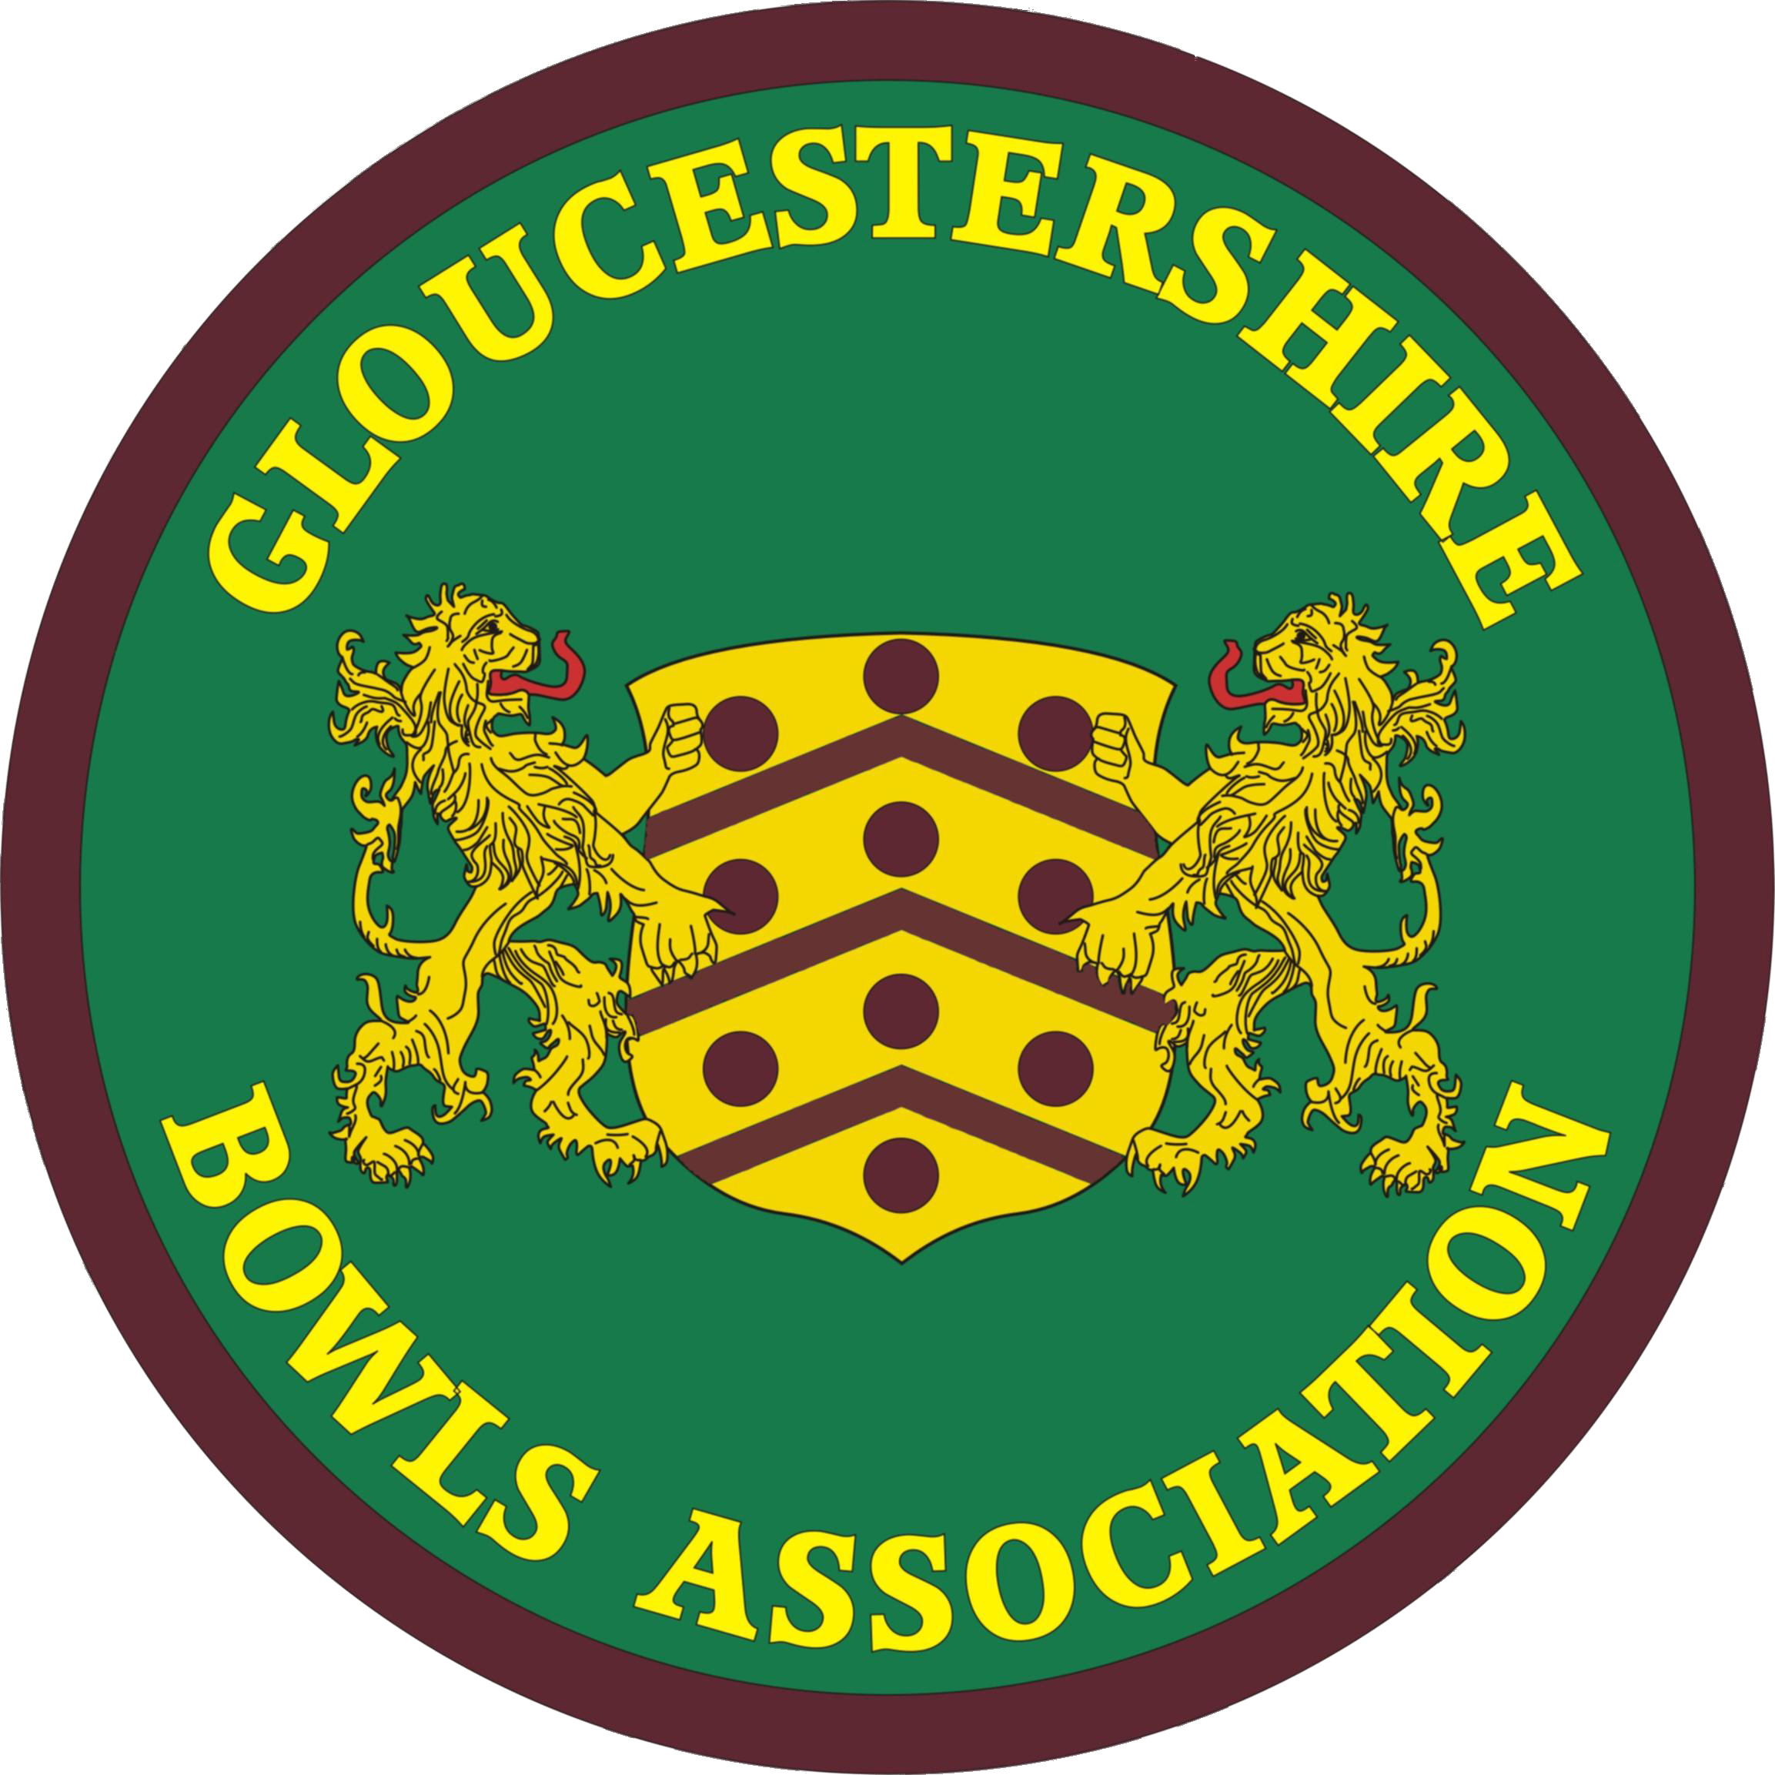 | GLOUCESTERSHIRE BOWLS ASSOCIATION  A Member of Bowls England.
G.B.A Women’s Division Annual Delegate Meeting
Whitminster Village Hall

Wednesday 13 October 2021, 1.30 p.m.

Minutes

- The Secretary opened the meeting by welcoming delegates. She referred to members who had passed away in the last year, for whom a minute’s silence was observed :

Joyce Nash (Gloucester Spa)
Sylvia Palmer (Fairford)
Angela Furhuraire (Gloucester Spa)
Averill Panes (Frampton)
Jane D’Elia (Fairford)

- Apologies 31 clubs sent representatives and 5 clubs sent apologies. 12 officers and officials were in attendance. Details in records.

- Amendments to minutes of meeting 17.3.21

- 8.4 should refer to 15 ends in the fours

- Ratification of minutes dated 17.3.21 . Ratified, and signed by Secretary

- Matters arising

  - Finals Day. Olveston BC. Thanks to Olveston for hosting two days. Usual hospitality. Results and pictures will be on Web site, but not yet. Thanks indeed to all clubs who have hosted the County for matches and competitions, particularly in this year of Covid difficulties and precautions.
  - Competition Entry Form. As noted, today is the final day. Entries are now closed, irrevocably.
  - Val Molton’s point about Women’s Top Club becoming 5 discipline proved not to happen.

- Treasurer’s report Avril Hole

Delegates have been provided with a summary of the accounts.

6.1 What a year! It seemed that every morning when I got up the goal posts had moved again. I had predicted that we would have a significant Loss again this year and there is nobody more surprised than me to observe that we do in fact have a small surplus.
6.2 Firstly looking at the Income it can be seen there are few entries. In the past the Finals Day Raffle and bank interest have both produced quite a sum. Several substantial Expenditure items do not appear including Examination fees, President’s Allowance and Room hire. The overall result – a Surplus for the year of £360.59. Page 2 shows that £24060.05 is currently held in the bank, cash and stock. The sum of £1673.40 within this sum is a P.C. cost for engraving, 2022 Competition money received before the year end, the remainder of the Barbara Overton legacy and GBYDS money.
6.3 Page 3 shows us the Surplus or Loss on each of the matches. I am happy that the overall loss on matches is only £117.92. At the beginning of the season with so many Away matches, uncertainty with travel costs and a great deal of confusion generally with regard to catering arrangements and costs, I feared we were facing a far greater loss overall. The match against Cambridgeshire may well have been our biggest loss had it taken place.
6.4 Looking at Competitions I am sorry to see a loss here too this year. The initial Income for Competitions this year was noticeably lower than the previous two years. For the first time this year it was agreed that upgraded umpire/marker expenses should be paid, resulting in expenditure of £236.00. I have also allowed for an increase of £25.00 in the P.C. costs for engraving. Hopefully there will be an increase in Competition entries next season to help restore a surplus.
6.5 The time has now come for me to pass on my duties to Angela Cary. I give you my very best wishes Angela for a very successful and enjoyable time ahead in your role as the Women’s Division Treasurer. I now ask you to accept your official badge. Please remember I am at the end of a telephone should you require any assistance.
6.6 Having now concluded my role as your Treasurer I hope I may be allowed to express a few personal comments.
- Your ‘county officer’ team is amazing! As I stated at the beginning – what a year! I shall not name people individually and you may or may not be able to identify them from my comments. Three of your team have experienced quite serious health difficulties before and throughout the year. Heart problems involving hospitalisation, cancer treatment involving chemotherapy. To my knowledge two of these ladies have also necessarily at the same time had to support very unwell husbands. These ladies have nevertheless attended to all their duties constantly.
- I am now thinking of two other members of your team who have frequently attended meetings and matches observing quietly, making every effort to ensure GBA Women’s Division achieves its best on the green. All this effort without actually participating as a player in any matches.
- Another member of your team doesn’t just work during the summer months but devotes much of her time during the winter preparing for the next year. This year must have been sheer hell for her. I would Just ask you to imagine the amount of discussion necessary with opponents, host bowls clubs, catering requirements, travel etc. in preparing for each individual match. This year having done all these tasks the dates of the first 13 matches had to be changed. Clubs changed catering arrangements. Two opponents cancelled altogether. Etc. etc. I am sure you get the picture.
- Another member of your team “the email Queen”. Constantly keeping all of us up to date with Bowls England, the Women’s’ Division, organising meetings with full agenda, reports and instructions relating to everything in the bowls world. Where this member has found the energy to carry out her tasks this year I’ll never know.
- Personally. I would urge you all to ensure a County Treasurer is found and I realise this Is equally on the shoulders of the Men’s Division. To be able to continue to produce an excellent, happy and united GBA I feel the duties necessary to achieve this must be shared and it is essential that the nomination sheet will have no vacancies in the year ahead.
- I have experienced at meetings that all decisions taken are often after much discussion and each and every aspect is always considered from the point of view of all members. I hope that you will gather from my comments that I have been extremely proud to be part of your wonderful team.
- I have enjoyed travelling and seeing more of the places around us. On many occasions I have been envious of the standard of play. I have enjoyed being introduced to so many new people and have always found a couple of bargain books at the various bowls clubs. And yes, okay, so dinner was always a highlight.
- When a person retires from any position within an organisation there Is often rumour as to why this has happened. I would therefore wish to make it clear why I am leaving you today. When you reach a certain age, it is often difficult to know how much longer you may be able to have sufficient sight to drive your vehicle. I love my campervan and there are still many journeys I hope to make, which is of course mainly during the bowls season. Accordingly, I would ask all of you to make me 2 promises. The first promise is that wherever you are please look out for a white campervan driven by a whitehaired old lady. Please smile and wave your hands in the air to her. The second promise is that when you spot this vehicle and the whitehaired old lady please smile and wave your hands in the air but stand well back on the pavement.

- Secretary’s report Lindsay Collin

  - There is no denying that this has been a difficult year, in every way and for everyone who has been regularly involved in the various aspects of running the County. I most certainly need and intend to thank many, many people who have quite literally ‘kept the show on the road’ through sometimes demanding difficulties, but I will do that a little later in my report.
I cannot say anything other than that I have found 2020 and 2021 so far to be very stressful. Fortunately, I love playing our wonderful game, so that I have been able to set the difficulties and the aggravation against the fun that I’ve also had, at least until two weeks ago. Factors that have made the last 20 months so difficult include :

- Obviously Covid-19 in all its manifestations, initially through a season where we were very lucky to be one of the few sports able to be played, albeit with careful precautions and often restrictions. This was then followed by a year where Covid still dominated everything, but for our sport the precautions and restrictions gradually eased. However, the main problem was that the ‘opening up’ of the sport to the more competitive aspects was necessarily ‘phased’ and caused much difficulty in relation to having to delay and reschedule our competitions at all levels and also the inter-county games were being constantly reassessed and sometimes retimed, as no doubt Myra will mention.
This obviously ended up with a fairly easy first half of the season, but – once the competitive playing commenced, bowls was available in abundance, right through as late as late as 20 September. Though that involved extra work for the competition secretaries and the selectors respectively, many of the products of their careful planning ended up with me being the conduit through which messages and details were then passed to club secretaries and delegates. As well as me fielding endless queries too, re just about everything.

- Secondly, the strange and unique happenings of 2020 and 2021 year were seized upon the ‘new management’ of our NGB, Bowls England, as an opportunity to develop strategies for the future of Lawn Bowling in England. Through often new communication mediums like Zoom and MS Teams, BE conveyed to the rest of us, in counties and clubs, not just the essential organisational changes to keep our sport functioning through the 2021 season in particular, but they used the time to develop long term strategies for the sport. Most of this came to clubs through myself, involving huge amounts of effort and work, time and again. I will come back to one or two things that have begun to change in BE and in our sport, in my later BE Report.

- Thirdly, I have been acutely conscious of the small, under-strength teams of ladies also working for us all, and the considerable loads that they have also had to bear.
You will recall several times during the last two years, me putting out pleas for help. The extra load involved in my having to be County Treasurer as well was and still is, very demanding for me.

- Expressing thanks is always very dangerous. One either gives general thanks, but accepts that particularly key individuals don’t get the plaudits that they deserve, or one mentions individuals, but risks getting lambasted for inadvertently forgetting somebody whose role is also vital.
Nevertheless, initially, I would personally like to thank all the Officers and Officials of the Women’s Division for their help and support to me throughout the last year. Gloucester has a superb team of workers. Not just the key WD Management Committee members, but the Selectors, the Competition Organisers and many others who keep the County running efficiently. Meetings all the while, decisions to be taken. So many County games to organise and attend, competitions to organise – it goes on. Believe me, I am so often reminded how lucky I am to have such dedicated colleagues in the WD. But I’m next going to be more specific, just in this very difficult year.

- Firstly, the Executive Officers. We know that Avril is literally leaving us today, so I’ll come back to her immense efforts later on. Myra I can reasonably call ‘Mrs Gloucestershire’. I suspect you have limited idea of how much and how continuously this wonderful lady works. Endlessly, and at times of the year that you might not imagine. She and I are on the phone all the while, sorting out problems or just bouncing ideas off each other.
Before, secondly, talking about our ‘teams’ of officials, I’d like to refer to one other individual, and that is Chris. This lady is amazing. Despite considerable health difficulties, she has added responsibilities, rather than removed them, and is not only a member of three groups – Selection, Competitions and the Management Committee itself – but the chair of all three. Wow !
As to the rest, both the under-strength Selectors, and the under-strength Competition Secretaries have been, to a woman, so, so hard-working and I thank them all, plus there’s the Management Committee as well. So thank you Barbara, Margaret, Myra again, Jan, Sally, Anne, Trish and thank you too Angela working her way into the Treasurer role, Maddie for her vital records role, plus anyone else that I’ve not mentioned – like Shirley. Heroes all !

  - If I could refer now to matters which may actually relate to myself, including being GBA Administrator, quite a lot has come your club’s way in the last year and recently, and even more will be coming in the next month. This is the busy season for admin stuff, and I would only ask that you do anything necessary to ensure that I receive the requested responses if they involve the women in your clubs. The following will be going out shortly :

    - 2021 Affiliation update – new affiliated members in your club, who played in the 2021 season
    - 2022 GBA Club Data Form – information for the 2022 Club Handbook
    - 2021 GBA WD Club Information Form – usual information about competition winners, young bowlers and players for the County List
    - Handbook request form

  - Not up to me to particularly comment on competitions, Jan will do that shortly. But I will briefly remark on two points :

    - Firstly, referring to the Benevolent Triples in September, I think that it went well and was enjoyed. Congratulations to Sally Rolls (Gloucester Spa), Pauline Gunn and Kay Gent (both Caer Glow), this year’s winners, again. I’d like - in this context - to minute the Association’s and the Women’s Division’s thanks to Gloucester Spa and Gloucester City for their ongoing fantastic support for this and other County activities. I am considering running the Benevolent again in September, though the timing of the Nationals in 2022 – because of the Commonwealth Games – will possibly be crucial.
    - The new Unified Competition Rules are now under review, bearing in mind observations and even complaints received this season. They must be ratified in time to be included in the 2022 divisional yearbooks, so in the next couple of months.

  - The GBA Joint Council Meeting will provisionally be on Saturday 6 November 2021 (see later notice re change of date to 20 November) and the AGM will be on Saturday 15 January 2022; please note that both of these will again be held at this location – Whitminster Village Hall. Information will be circulated in the next week or so on the JCM themes, but it is likely to be to do with matters under consideration by Bowls England, as well as some changes in the GBA Constitution & Rules.

  - National Championships : I managed to attend for the whole two and a half weeks in Leamington and saw almost every game in which Gloucestershire competitors took part. Thanks to those people not just from my own club, in abundance, but occasionally others - Cam, Gloucester City, Olveston, Fairford, Cheltenham, Barnwood, Henleaze, Cheltenham Spa and others whose fellowship I shared at some point. An interesting event overall – some good points, some less so.
Re the women in particular, we must congratulate Kingswood & Hanham women, most particularly Val Molton, who represented the County in 5 events, notching up several excellent personal performances. The K & H Four (including Val, with Pam Salvage, Sue Osborne and Jan Williams) also did well in reaching the Qtr-Finals. Barbara Whitehead & Rachel Hughes, of Gloucester City, reached the Qtr-Finals of the Mixed Fours.

  - Annual Luncheon & Presentations Another matter currently involving some effort for myself, Myra (& Tony) and Sue Latham in particular, is the organisation of the GBA Annual Presentation Luncheon at Hatherley Manor, on 17 October. Looking forward to it very much. Luncheon attendance again is high. Particular thanks to Sue for helping me out this year.

  - GBA Handbook and Web sites I have said at the previous meeting that the pattern of the now three GBA handbooks will continue again in 2022. The signs are that these were well received, though I remain constantly disappointed that people don’t always seem to exploit the handbooks as information sources. I often get un-necessary enquires for information that is actually in the WD Yearbook or in the GBA Club Handbook.

I try to keep both the WD Web site and the Gloucestershire Bowls Portal up to date, but occasionally I’m slow to put up eventual results in particular, for which I apologise – that is the case just now I fear. I’d like again to thank Gill Meadows for being around with her trusty cameras on certain occasions and for her professional images.

  - Thanks to David Rolls for his efforts in relation to coaching and development with the County women this last year. Very good turnouts often and much appreciated by those taking part. Thanks also to other coaches such as Gill Meadows, Ken Tudor and John Lawson. David was also massively involved with the Youth Academy and also with the women’s Amy Rose team, along with several coaches and with Team Manager Val Molton. Excellent support there from parents also, which is absolutely vital.

  - Invitations to play We continue to have problems re ‘Invitations to play’ for the County : (1) Some players are not reliably sending in their non-availability to Section Selectors and consequently attracting bans for later turning down invitations. This year is worse than ever. (2) Bank transfers are being made, for match fees, but without any supporting paperwork, causing extra work for Avril in determining who has made such payments.
In relation to the former, I apologise that I still have some banning letters to write to a few players who simply had not bothered to inform their Section Selectors of their complete availability. So depressing to risk affecting players’ enthusiasm, but there really has to be some sort of sanction.

- Match Secretary’s report Myra Savage

Here we are again arranging matches for next season. It feels like I have been arranging and re-arranging matches continually for the last year or so !
  - It has been a very challenging season this year due to the fact that we could not play any county matches before 21st June; this meant that everything before that date had to be rearranged for later dates. This made it very condensed and extremely busy especially September, which was manic. At this point I would like to thank all the officers – including Past Presidents - who helped me, especially during the National Championships period when Lindsay had to be at Leamington to represent the county as we did not have a Presidential team there.
  - In term of results this year, we won all of our friendly county matches, mixed friendlies we won 3 and lost 1, MEL games for which there were only four, due to Worcester pulling out permanently and Cambridgeshire withdrawing from this season, we won 2 and lost 2 but actually ending up second in table, due to having two wins by good margins. Hopefully - fingers crossed - Cambridgeshire will come back into the MEL next season.
  - There is a MEL meeting on 10 November when we shall be discussing whether all rules, etc should go back to as before COVID-19. We played a MEL match very late in season this year versus Oxfordshire and all ladies enjoyed having a MEL game that late in season. I contacted Oxfordshire to see if they would keep this match in September, but unfortunately they did not want to do so. I have since contacted Leicestershire to see whether they might be able to change, and they are looking into this and if not September they may be able to change to August.
  - However on to next season, which I hope will be back to normal. I have very few matches arranged and confirmed yet as the season finished nearly a week later and since then contacting Match Secretaries at other counties and clubs has been proving difficult. It is still really difficult finding venues with reasonable costings for matches. Most of them seem to have put their costings up slightly this year and probably more next year.
  - Must ask yet again for clubs to offer their greens for county matches and to try and keep costs as low as they possibly can. As I have said before we do not need a fantastic spread, just a simple two course meal will suffice. I will try and accommodate them if we happen to need greens in those specific areas, as it does change from season to season. Many thanks again to all clubs who have already generously offered their facilities for county matches. We are increasingly grateful for all your help.
  - As I cannot let you have confirmed dates yet, but if you have any queries on matches or venues, I am happy to answer. If any ladies particularly need to query dates regarding booking holidays, etc please feel free to give me a ring in the next month or so and I will answer your questions. As you know yearbooks with final fixtures are not given out until the March Delegate Meeting.

- Competition Secretaries’ Report Jan Lee-Cooper

  - Sadly, as everyone is aware, we have not been able to hold a face-to-face Delegates’ Meeting since October 2019 and therefore this season we have been even more reliant on Lindsay for maintaining regular communications with us.
  - We managed to play all our scheduled competitions and held our Finals at the end of August/beginning of September; there being the need of more than one day because Val Molton of Kingswood & Hanham was so successful and reached five competition finals (individually and as a team member). These days were well-supported and both hosted by Olveston BC. Val went on to represent us at the Nationals in Leamington, as also did the Finalists-only in all but the Fours competition.
  - The Interclub Semi-Finals and Final were played at Henleaze BC in good bowling weather (which we seemed to have had most of the season). The Section qualifiers were Olveston BC (Bristol), Cheltenham Spa BC (Cheltenham), Barnwood BC (Gloucester) and Frampton-on-Severn BC (Stroud). The eventual winners were Barnwood BC with an extra end being played against Olveston BC to determine the result. Well done to all participants and ‘Thank you’ to both Olveston BC and Henleaze BC for their hospitality.
  - Our Joint Annual Presentation Luncheon is this Sunday (17 October) when we hope to see many of you there to congratulate the finalists again as they receive their trophies – of both the Women’s and the Men’s competitions.
  - I would also like to take this opportunity of saying a very big ‘Thank You’ again to all those Clubs, Officers, Officials and Supporters who contribute to making the Competitions a success. An awful lot of hard work and effort goes on in the background, pulling these events together.
  - Today’s meeting is the deadline for competition entries for next year – there will be no late entries accepted - and we look forward to having more individual entrants across all competitions once again. Please reiterate to your Club’s entrants what has been said on previous occasions about fulfilling their commitment to the competitions in that County Competitions lead to the National Championships and everyone should be available to carry on competing in the games (representing Gloucestershire) to be played at the Nationals venue.
  - We are hoping to have a straight-forward season next year and that we can all enjoy playing bowls to the best of our abilities without hindrance.

- Bowls England Delegate’s report Lindsay Collin
10.1 2021 National Championship winners Lincolnshire won the Walker again, Devon the Johns and Somerset the Amy Rose. Kings BC won the Women’s Top Club for the third time in a row.
10.2 Dates of the 2022 National Championships will be Thursday 25th August to Sunday 11th September inclusive, a week later because of the Commonwealth Games (itself 28th July to 8th August 2022) and all the clearing up. Possible regional events.
10.3 National Presentation Dinners discontinued. In future just one dinner, in February. Highly debatable decision. Secretary read out some of the planned awards, not all sensible, and certainly far less attractive to potential participants, compared to the present standard trophy presentations
10.4 2021 BE Counties Meeting at Loughborough University on Friday/Saturday 26/27 November 2021. Ian Gauld and I will represent the County.
10.5 National Competitions 2022
  - Revised formats : All team competitions 18 ends; Triples 3 wood; Pairs 4 wood; singles all unchanged . Will result in changes in our own Unified Competition Rules
  - Counties must be the same as national in terms of formats
  - Reduced numbers of qualifiers again
  - Inter-county events will remain knockouts, but clashes irritating in 2021 will be minimised
  - Copious photos of 2021 Nationals on BE Web site. Can be found at :
https://buy.mysportphotos.co.uk/?Action=_VC&id=385198179&ppwd=national%20bowls%20final%202021
10.6 Huge changes coming in our sport. Much active debate, including at BE Counties Meeting

- Benevolent Secretary’s report Shirley Lewis

  - Secretary thanked everyone who had helped delivering gifts and cards
  - She expects to be away 30 October to 16 November. Club Secretaries or Delegates, please deal with requirements while she is way (£8-10 generally) and she will settle up on her return
  - Greetings for Christmas and New Year
  - [Details of accounts given]. Expenditure £126.26. Income none. Money in hand or bank account now £675.34.

- Nominations.

12.1 Latest [separate] nomination sheet provided prior to meeting. Four positions only now have no nomination : Vice-President, Stroud Section Selector, Cheltenham Section Selector, Safe- guarding Officer. [ Note: Section Selectors will be solved, one by a nomination made after this Delegate Meeting, the other by co-option by the WD Management Committee. ]

- Election of 2019/20 Officers and Officials

  - No nominations contested, so all those positions confirmed. President Maureen invested and took over as Chair of the meeting. Following Officers and Officials elected unanimously :

Post | Name | Club
Immediate Past President | (None)
President | Maureen Richards-Smart | Caer Glow
Vice President | [ Required ]
Secretary | Lindsay Collin | Kingswood & Hanham BC
Treasurer | Angela Cary | Tetbury BC
Match Secretary | Myra Savage | Painswick Falcon BC
Bowls England Delegate | Lindsay Collin | Kingswood & Hanham BC
Representative to GBA Joint Executive Committee | Linda Bennett | Moreton in Marsh BC
Bristol Selector | Margaret Drayton | Olveston & District BC
Cheltenham Selector | [ Has now been offered ]
Gloucester Selector | Christine Magee | Pineholt BC
Stroud Selector | [ Will be co-opted ]
Bristol Competition Secretary | Janet Lee Cooper | Olveston & District BC
Cheltenham Comp Secretary | Janet Tomlinson | Bishop’s Cleeve BC
Gloucester Comp Secretary | Gill Fry | Gloucester Spa BC
Stroud Competition Secretary | Myra Savage | Painswick Falcon BC
Bristol Section Rep | Ann White | Henleaze BC
Cheltenham Section Rep | Margaret Davies | Bishop’s Cleeve BC
Gloucester Section Rep | Chris Magee | Pineholt BC
Stroud Section Rep | Sally Rolls | Frampton on Severn BC
County Records Officer | Maddie Hale | Fairford BC
Benevolent Secretary | Shirley Lewis | Kingswood & Hanham BC
Safeguarding Officer | [ Needed ]

13.2 Secretary gave a fulsome appreciation of retiring members who had been notably important to the County in a range of roles, and made suitable presentations : Past President Trish Nunn (Ardagh), Past President Anne Beaven (Dowty) and retiring WD Treasurer Avril Hole (Cotswold). [Tributes available]

- Proposals

No proposals

- AOB

  - Margaret Davies has a guidance sheet available for any clubs wishing to encourage school children to try the game, based on Bishop’s Cleeve’s experience
  - Competition dates would depend in 2022 on match fixture dates, so please treat dates of comps as provisional for the moment
  - Sally Rolls proposed a vote of thanks to the Secretary. Unanimously agreed

The meeting closed at 3.45 pm

GBA Women’s Division 2022 Delegate Meetings - Wednesday 16 March, 13 July and 12 October. All 1.30 pm at Whitminster Village Hall.

Signed : (President)

