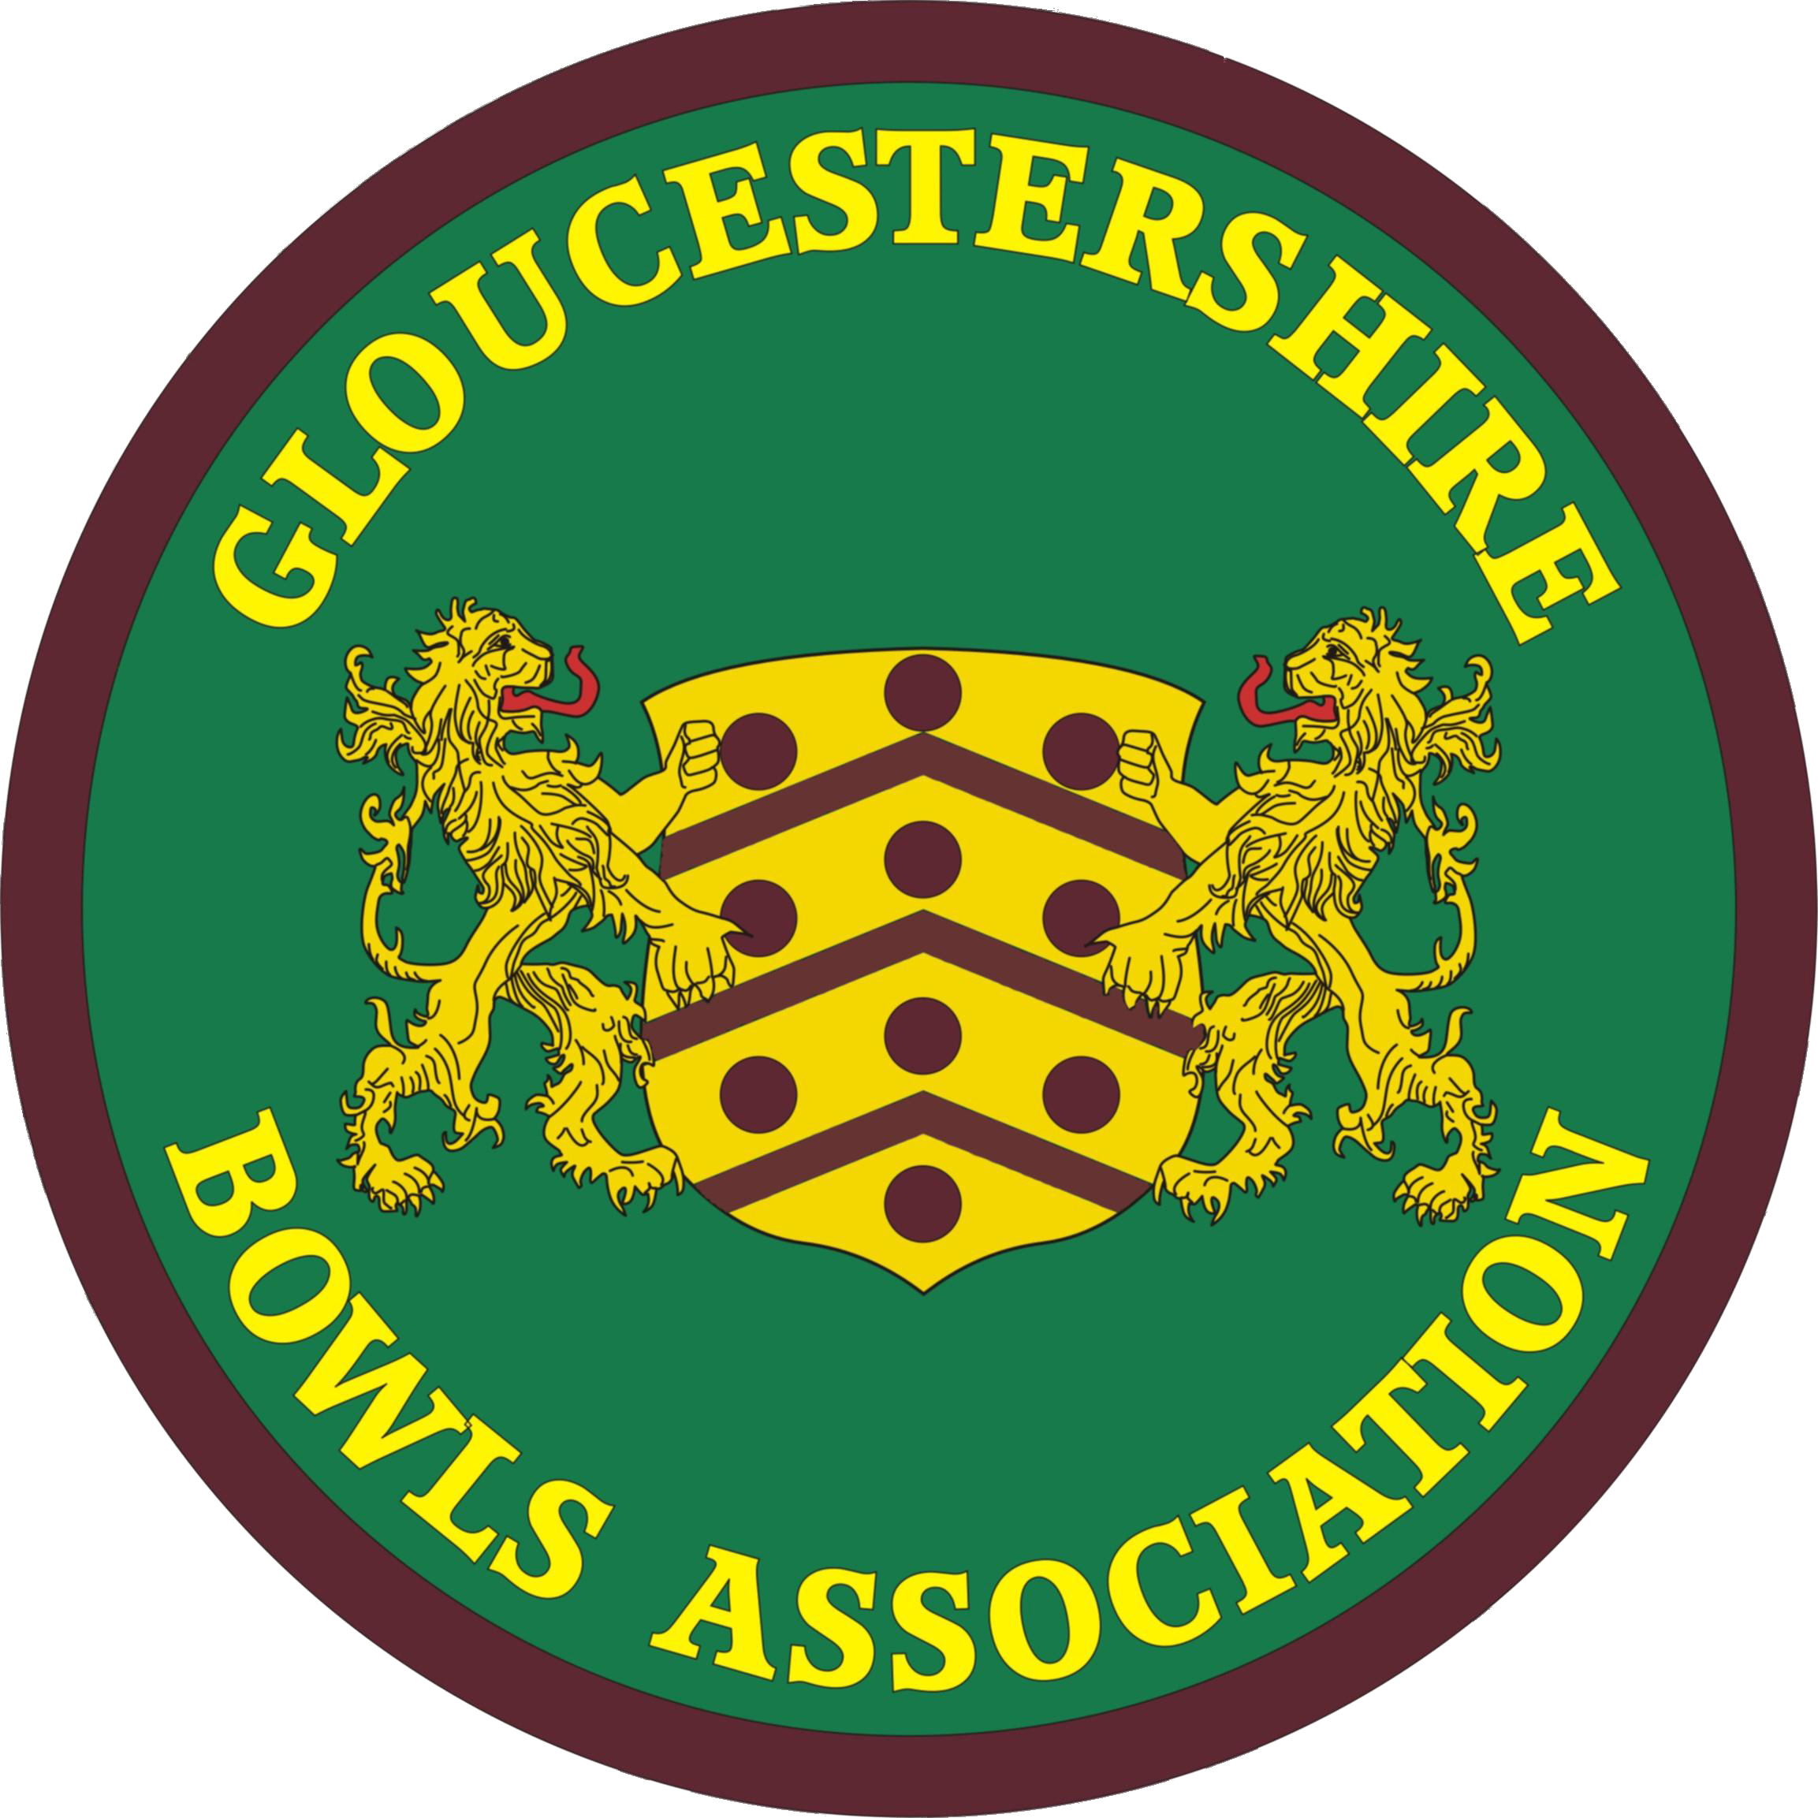 | GLOUCESTERSHIRE BOWLS ASSOCIATION  A Member of Bowls England.
G.B.A Women’s Division Delegate Meeting
Whitminster Village Hall : 1.30 p.m.
Wednesday 16th March 2022

Minutes

In the absence of WD President Maureen Richards-Smart, the WD Secretary, Mrs Lindsay Collin, opened the meeting by welcoming delegates. A minute silence followed for a lady who had passed away since the last meeting : Hilda Brace (Bristol Omnibus).

- Apologies 23 clubs sent representatives and 8 clubs sent apologies. 13 officers and officials were in attendance. Details in records. Disappointing attendance by delegates.

- Amendments to minutes of meeting 13.10.21 None

- Ratify minutes dated 13.10.21

- Matters arising None not already on the main agenda

- Secretary’s Report Lindsay Collin
5.1 State of the County Affiliations of women in the GBA have been very severely affected by Covid – 1013 at the end of 2021, compared to 1220 at the end of 2019, some 17 % down. The men’s affiliations are over twice this number, 2251 compared to 2418 in 2019, so only some 7% down, giving an overall reduction of 10%. This will relate in due course to allocations of affiliation income between the two divisions, giving more than 2/3 of our total income to the Men.
Numbers on the women’s County List are also still seriously down, compared to a baseline of 134 in 2019; 112 only this year, though 2021 was a nadir, just 93.

  - General WD administrative matters :

- New 2022 WD Yearbooks and GBA Club Handbooks are available today. [The MD Yearbooks will be distributed at the MD Delegate Meeting on 26 March]. Please take Yearbooks for anyone who is not here, to avoid postage costs and organisation; Secretary went through the remaining packages of Handbooks/Yearbooks, attempting to get as many as possible taken and delivered.
Apologies given for any mistakes in the publications; any errata will be notified and listed on the Gloucestershire Women’s Web site or Web Portal, in due course. Noted that the Secretary will hold a small supply of ‘spare’ Yearbooks and Handbooks for those who may wish to make additional purchases.
- The Web Portal and the WD Web site are just now being updated and will be more so up until the season starts. County teams from last season still there on the WD site. (www.gcwba.org.uk), but will be replaced once the new playing season commences. Secretary inquired on who routinely goes to our Websites ? Gloucestershire Web Portal is www.gloucestershirebowls.org.uk . Please use these sites.
- In the WD Yearbook are outline details of the GBA Annual Presentation Luncheon, Sunday 23 October 2022. A flyer with menu will be provided in July; please ensure that this is displayed in your clubhouse in due course. We would like to persuade clubs to make a commitment to come, preferably in a group, at an early stage, to assist planning. Quite a few favourable comments were made after the luncheon last October, which seemed to be much appreciated.
- Also mentioned in the Yearbook is the Benevolent Triples, but without dates. Will send an e-mail after this meeting, with full details, including a flyer for display. The experiment forced upon us last year, essentially remains the same this year, due to the timing of the Commonwealth Games plus the new Regional Finals taking up part of late July, so I have decided to hold the Benevolent Triples in September again : Friday 16 September 2022 at Gloucester City & Spa. There is still plenty of time to enter this competition, so see flyer very soon. It is a very pleasant and relaxing day, but also competitive and still leading to a possible national title.
- County Match matters Lots of these to consider, so will be dealt with in a separate agenda item (10).
- Myra and I attended the Middle England League meeting in Coventry a week ago; a good session. Now only six teams, due to the unfortunate loss of Worcestershire. Happy to say that Cambridge remain with us, but not sure for how long ? Myra will report on this and other MEL developments.
- County and WD Information is still sent by the County Administrator/WD Secretary to the Club Secretary, as well as quite often to the WD Delegate. This general comment for the info of the several new WD Delegates. Your WD Delegate should once again please ensure that your club is kept abreast of general GBA matters, not just the WD-specific matters. Minutes of WD Management Meetings and the GBA Joint Executive Committee (which are on the Web Portal) are a reliable and reasonably complete summary of recent information. MD minutes only on the MD Web site (at www.glosbowls.co.uk )
- WD Officials All posts were previously filled for this season, other than the Safeguarding Officer, and it’s really encouraging to see some new names on the officer/official list (in your Yearbook). Thanks to all those who have taken on responsibility this year.
However, I was dismayed to receive a letter from Christine Magee at the conclusion of the last WD Management Meeting, on 7 February, resigning from the roles to which she was elected in October – Section Representative for Gloucester and Section Selector for Gloucester. Christine will still retain the role to which she has been appointed by the WD Management Committee – Advisor to the Competition Secretaries, recognising her massive knowledge in this area. I would like to thank Chris for everything that she has done for the County over many years, immensely so; many of us have asked her to reconsider, verbally and in writing, but I have now to assume that she will not do so. At least not for the moment. I’m grateful at least that she will continue her work on Competition matters, with Jan, Myra, Janet and Gill. I will circulate job descriptions for the two roles now required for the Gloucester Section and would ask genuinely-involved members of our bowls community, with the appropriate experience, to consider coming on board.

  - Comments on GBA meetings & developments since last WD Delegate Meeting in October :
WD Management meetings

    - WD Management Committee Meetings on 1 November 2021 and 7 February 2022. Minutes of these two meeting are on the Web Portal, the latter in draft, as unratified.
    - WD Selection Meetings Several so far, under Chairmanship of the President, Maureen. Issues related to these brought up under agenda item 10. Meeting dates of course in the new WD Yearbook.

Changes in the GBA Joint Executive Committee (JEC)

- LC updated the committee on the recently-appointed 2022 JEC positions :

    - David Rolls - Incoming Chair of the JEC
    - Lindsay Collin – Still Secretary to the JEC
    - Lindsay Collin - County Administrator; George Thomas - Deputy County Administrator
    - Roger Harrison - GBA Unified Match Secretary (though really shared with Myra Savage)
    - County Treasurer - Pat Yates-Whittaker stepping into this role
    - WD co-opted member – Val Molton appointed by WD Management Committee

- Constitutional 5:5 gender balance retained, with County Treasurer ex-officio.
- GBA roles more broadly. The 2022 GBA Club Handbook gives a comprehensive summary.
GBA general meetings

JCM at Cotswold BC (20 November 2021) dealt with:
- Investiture of GBA Presidential teams completed. Our own Maureen Richards-Smart and Martin Bevan, MD President. Other Officers, see in 2022 Club Handbook.
- Proposals for changes in GBA Constitution & Rules discussed, but issues remain. MD have unfounded complaints about role of the Joint Executive Committee.
AGM held on 15 January 2022 at Whitminster Village Hall. Well-attended, if relatively brief. Usual format and content :
- Chairman’s Report
- Administrative points, including grateful thanks to all who have served the GBA in various capacities in the last year.
- GBA attainment in Nationals and at County level. Congratulations to all who gained success, but Val Molton very much starred for the WD.
- Massive changes at the national level, in Bowls England, dealt with. Much on communication developments, including direct contact with clubs and enhanced use of social networking (Facebook, Twitter, Instagram). See item 9.1 in these minutes.
- Acting County Treasurer’s Report.
- All Joint Executive Committee nominations agreed.
- Just one proposal (on badging for Junior inter-county matches); agreed.

GBA Joint Executive Committee meetings Minutes on the Gloucestershire Web Portal.

- Treasurer’s report Angela Cary
- Treasurer report is quite brief for this meeting, as not much happens until we start bowling !
- Monies into the bank amount to £2494.90, which is £218.40 late affiliations from last year and the remainder is county competition entry money
- Expenditure of £3081.05 , which covers Whitminster Hall hire charges for the year, engraving costs for the trophies, GBA WD Yearbooks, National Championship payments to BE, and NFU Insurance
- So we end the month of February with a balance of £1171.66
- Balance of savings account is £22,006.91, which has gone up by 73p with the interest over the last few months !

- Match Secretary’s report Myra Savage
7.1 All matches are now arranged and confirmed. Still awaiting costings for some away games but this is par for the course every year. There has been a significant increase by some clubs in costs for meals. Quite a few are now charging rink fees. In comparison some clubs do not charge any more than 10 years ago. I do try to impress on them that we do not need a banquet just a simple two course meal and that they can run a raffle for the club’s benefit etc. but after saying all the above we will have to live with it and maybe look at increasing match fees if this trend continues.

Matches are as below :

Wednesday | 11/05/2022 | Somerset - FRIENDLY | Chew Stoke B.C. | 1.30pm
Sunday | 15/05/2022 | JT Practice Match | Falcon B.C. | 2.00p.m.
Tuesday | 17/05/2022 | Oxfordshire - MEL | Cheltenham B.C. | 1.30pm
Friday | 20/05/2022 | Leicestershire - MEL | Chipping Campden | 1.30pm
Sunday | 22/05/2022 | JT Practice Match | Falcon B.C. | 1.30p.m.
Tuesday | 31/05/2022 | Worcs - FRIENDLY | Broadway B.C. | 1.30pm
Wednesday | 01/06/2022 | Warks Mixed | Victory Park B.C. | 1.30p.m.
Saturday | 04/06/2022 | Johns Trophy Prelim v Cornwall | Tiverton West End | 1.30pm
Thursday | 09/06/2021 | Cambridgeshire - MEL | Iver Heath B.C. | 1.30pm
Friday | 10/06/2022 | Berkshire - Friendly | Tetbury B.C. | 1.30pm
Saturday | 18/06/2022 | John's Trophy R1
Sunday | 19/06/2022 | Amy Rose v Warwickshire | Bishops Cleeve B.C. | 11.30a.m.
Wednesday | 22/06/2022 | Hereford - FRIENDLY | St.Martin's B.C. | 1.30pm
Saturday | 25/06/2022 | GBA v Somerset Walker Cup | Clevedon B.C. | 1.30pm
Sunday | 26/06/2022 | Men v Ladies | Cam B.C. | 2.00p.m.
Wednesday | 06/07/2022 | Warks - MEL | Barnwood B.C. | 1.30pm
Saturday | 09/07/2022 | John's Trophy Round 2 |  | 1.30p.m.
Saturday | 23/07/2022 | John's Trophy Quarter Finals
Friday | 29/07/2022 | Northants (MEL) | Fairford B.C. | 1.30pm
Saturday | 13/08/2022 | President's Day | Caer Glow B.C. | 1.30p.m.
Wednesday | 17/08/2022 | Glamorgan - FRIENDLY | Caer Glow B.C. | 1.30pm
Sunday | 21/08/2022 | GBA (Mixed) v Swindon & Dist BA | Victory Park B.C. | 2.00p.m.
Friday | 02/09/2022 | Wiltshire - FRIENDLY | Wotton under Edge BC | 1.30pm
Tuesday | 06/09/2022 | Hampshire FRIENDLY | Alton Social B.C. | 1.30pm
Tuesday | 13/09/2022 | Somerset Mixed | Mark Moor B.C. | 2.00p.m.
Thursday | 15/09/2022 | Hereford Mixed | Brimfield & Little Hereford B.C. | 1.30p.m.

7.2 We have mostly home matches this season so not a lot of travelling is required. We will definitely be requiring 3 coaches this season. At the last JEC meeting, I queried coaches to two of the GBA mixed matches but it was ultimately agreed not to use coaches for these this year. Looking at the quotes for this season it seems that most prices have gone up by about £20 per coach which is not surprising when looking at fuel costs. However, it is possible that this might change due to the situation regarding fuel at present. Fingers crossed it stays as it is.
7.3 As you will see we are playing Cornwall in the preliminary round of John’s Trophy at Tiverton West End B.C. This is our match but played halfway between counties. When we win this round, we will then hopefully have Worcestershire which will be a nice close venue but as it is the John’s Trophy we have a policy to have a coach. We decided at Management meeting that we would have a coach if needed.
7.4 Lindsay and I attended the MEL meeting on 9th March. This was a good productive meeting and many things were addressed. Other counties are paying a lot more than we are for coaches so are trying not to use them.
a) There was a discussion on playing on neutral greens halfway between counties, which we do with Cambridgeshire. It is more expensive to play on neutral greens, as we need a coach every year as opposed to one every other year. The downside to this is it is a much longer journey every other year and most counties were opposed to travelling such long distances.
b) Concern was raised over costs of meals, with some clubs charging up to £10.00 for meals. It was agreed that we did want a meal after being out all day travelling and play but to go no higher than £8.00 in price. It was also discussed about some clubs charging rink fees. In the past no club ever did this as it was more of less considered a bit of an honour to be asked to host a county match, but times have changed and as people have got older doing the catering is not something they want to do. However, it was concluded that we consider asking clubs to keep things to a minimum just a simple two course meal, tea/coffee on arrival and not charging rink fees.
c) We will be returning to MEL rules as before Covid, and having one non-John’s Trophy player on each rink. Last year’s JT players have been sent to MEL Secretary, and those names will be used, up until 1 June this year, when this year’s JT squad will come into play. All matches will be 21 ends unless there are extenuating circumstances e.g. weather - whether too hot, raining etc.
d) There was talk of playing six triples if smaller counties were struggling for players, but this will only be allowed in extreme circumstances.
e) Players in MEL matches will pay for their own drinks after matches and there will be no top rinks prizes nor President’s gifts. This is all to keep costs down.

I hope we have a good successful season and keep winning.

- Competition report Jan Lee-Cooper
  - Here we are again – getting ready for the new season to commence under what should be considered as “back to normal” conditions. You should have collected the 2022 Yearbooks and Handbooks for your Clubs and individual competitors before this meeting began. When distributing these to those individual competitors, please stress to them the importance of checking the accuracy of their names/contact details. Any amendments needed should be notified to their Section Competition Secretary as soon as possible, and before competition rounds begin.
  - We would also remind everyone who has entered a competition of the importance of familiarisation with the rules as printed in the 2022 Yearbook, which are essential reading (see 8.6 below). If anyone CANNOT continue with participation in the Competitions, (including the National Championships), they must inform their Section Competition Secretary as soon as possible as, if too many people drop out of any one Competition, in fairness to the remaining competitors, a re-draw may be necessary.
  - This year, as many of you will be aware, the Commonwealth Games are being held from 28 July until 8 August, with Lawn Bowls being played at Leamington Spa from 29 July until 6 August. The National Championships then commence on 25 August until 18 September, once again with complete inter-mixing of the women’s and men’s Games (see https://www.bowlsengland.com/wp-content/uploads/2022/01/BENF-22-Schedule-FINAL-v.3.pdf for schedule).
  - At this point in time, we are unable to comment on how likely it will be that it will be winners only who will represent their County; this should be known in the next week or so. It is possible that some of our runners-up may be included in the Nationals, which would be good.
  - With regard to playing formats for competitions, the GBA unified competition rules make reference to 'current Bowls England regulations' – we therefore cannot commit to formats in our own GBA competition rules while they are still liable to change. The formats for County Competitions (that do not lead to the National Finals) are: Champion of Champions and Unbadged Singles - 4 bowls, 21 shots; Inter-Club 2 rinks, 4 players each rink, 2 bowls per player, 21 ends.
One big, big change to be aware of is that, from this season, both rinks in the WD Inter-Club Competition will play on the same green (i.e. challenger’s) simultaneously, thus avoiding possible differences in play format of the teams arising from weather or other conditions/occurrences.
  - Thank you for your attention; we look forward to getting out there and playing our best bowls ever !
  - Secretary elaborated on some of the key 2022 Competition Rule changes, using the document circulated to clubs immediately prior to this meeting (with changes highlighted in red). She ran through at the meeting, but will also draw attention to these changes in a separate e-mail to clubs.

- Bowls England Delegate’s report Lindsay Collin
Importance of using and visiting the Bowls England Web site. Recommend making the BE ‘News pages’ your home page for this (www.bowlsengland.com/news-items), so routinely picking up on the most recent developments.

  - Just so much to report on Bowls England. Many points can be picked up initially in the January 2022 GBA AGM minutes (items 3.13 to 3.15), including :
- Future BE Strategy. Key objectives. Governance
- Competition changes
- National Championships
- Commonwealth Games
- Direct communication with clubs. Nominated club contacts now provided to BE
- Dedicated fund-raising advice and opportunities. Regular circulations to clubs, via myself.
- The Extra End Podcast. Interviews (the first with Tony Allcock. YouTube
- Workout videos, if keen on physically preparing yourself for your sport. YouTube
- Webinars. Including: Fund-raising; Communications; Social Media. YouTube.
- Live steaming of events. Nationals. YouTube
- Recruitment. Including Big Bowls Weekend. Huge
- ‘Club Life’ or ‘Club stories’ videos
- ‘Club together’ e=mail newsletters
- ‘The Jack’ fortnightly e-mail newsletter.
  - Bowls England AGM was two weeks or so ago, in Leicester, with the Secretary/Administrator and George Thomas attending to represent Gloucestershire. Ian Gauld had joined Secretary at the Bowls England Counties’ Meeting at Loughboro’ University in November. Various matters came up at the AGM, including :
    - New President is Terri Keen (Bucks), after 2 years of Paul Robson (Hants), himself now IPP. SVP Deepak Tanna (Leicestershire).
    - All fees – affiliation and competition entry - remain unchanged for yet another year. Affiliation now the same since 2005 !
    - Three propositions all voted upon and passed :
      - Reinstatement of badge presentation ceremony at Leamington
      - John’s Trophy to become a ‘Round Robin’ competition again in 2023
      - Reinstatement of Bowls England Presentation Dinner (one, unified) in November 2022
- Presentations on ‘Pay to play’, ‘New introductory bowls format’.
  - BE Regional meetings seemingly cancelled. ‘Counties Meeting’ this year was good. Monthly ‘drop-in’ sessions on Zoom, for County Administrators, have been a useful development. Re the regional aspect, we still have ‘Group West’ a sort of SW counties ‘forum’, which Secretary chaired yesterday in Clevedon, so we still have contact with other counties specifically in our own region.
  - Following from the AGM summary (above), on the same night, the inaugural Bowls England ‘Awards Evening’ took place. Reservations by myself and the GBA JEC on all sorts of aspects of this new development, previously expressed to Bowls England, but Gloucestershire did embrace this new idea on the inaugural occasion. Pleased to say that we had three nominations in two categories, the premier one being the long-established and prestigious ‘Bowls England Club of the Year’ for which 2 Gloucestershire clubs made the shortlist of 5 (Bristol St Andrews BC; Kingswood & Hanham BC). Peter Jones - Bristol St Andrew's BC - shortlisted in another category). Forgive me if I’m a bit proud, but it was my own club, Kingswood & Hanham, who scooped this major national award. Well done to us ! Congratulations signalled from the meeting.
  - National Competition entries closed a week or so ago. Draws not yet available on Web (Bowls England Competition Portal www.bowlsenglandcomps.com ). Should be disclosed by end of this month. We also await information about how many qualifiers we, Gloucestershire Women, will have in the various competition events (most probably the same as last year i.e. 1 in each)
  - Please also note that two Gloucestershire clubs, Kingswood & Hanham BC and Cotswold BC, have also been awarded BE Regional Finals Days – K & H the Walker Cup, and Cotswold the Balcombe Trophy, both on Sunday 17 July 2022.

- County Match Report
  - Selectors Little more to say. We started the year with a full complement, but now looking for a new Section Selector in Gloucester.
  - Team Manager Excellent news that Ann White has agreed to be appointed the WD Team Manager role for this season. Ann has massive experience, is well able to command the respect of the County’s top players, and is generally not shy in coming forward with her views !
  - Development / County Coaching The Selection Committee have asked David Rolls, the County Coaching Co-ordinator and the County’s top-qualified coach, to again become involved with the WD County Match Squad. This will broadly involve four aspects :
    - Direct observation and advice on match days, specifically and only through the Team Manager (the only person allowed to talk to players in the main inter-county competitions (John’s, Walker)).
    - Specific match-prompted team coaching imperatives, if required.
    - General player and team development through the unofficial, already-existing County Ladies coaching programme and any other coaching initiatives thought possible and necessary. Very difficult to elaborate on for now, until the demand is assessed, in requests emanating from two letters sent out by Secretary last week – to County List players and to Club Secretaries. Coach Bowls Level 2 coaches would need to be involved in any new initiatives, which could possibly be organised in Sections.
    - Specific Amy Rose Bowl squad coaching sessions, starting early and building up to the first Amy Rose game on 19 June. Val Molton to continue as Amy Rose Team Manager.
  - County Match uniform The decision was taken in November by the Joint Executive Committee to support a new ‘County Match Uniform’ and to appoint a Sub-Committee (none of whom then on JEC) to investigate the implications and options. A special JEC meeting was held on 20 January to review the Sub-Committee recommendations and take the formal decision to proceed. Further aspects were considered at the JEC meeting on 12 February, subsequent to which the Administrator and three members of the Sub-Committee dealt with the suppliers, Karuta of Weston-s-Mare. Shirts to be supplied by County (this year) and by Divisions (in subsequent years); all other garments to be purchased by players. Designs displayed to delegates.
  - County List availability Fixture list now confirmed. Secretary will circularise all County List players, shortly, instructing them as to how to advise the Selectors of their non-availability.
  - Two further points continue to occur in relation to player non-availability notifications :
    - We still have problems re ‘Invitations to play’ for the County. Some County List players are not reliably sending in their non-availability to their Section Selectors and consequently attracting bans for later turning down invitations. Last year was worse than ever.
    - Bank transfers are being made, for match fees, but without any supporting paperwork, causing extra work for Avril (last year) in determining who has made such payments. This must please not happen in 2022.
  - In relation to the business of banning, outstanding bans from 2021 are being written off, due to the extended circumstances. Lengthy discussion took place at the last WD Management Meeting on the ‘Banning Procedure’ (see summary below) and the various options available. This proved somewhat inconclusive, with divergent opinions aired. Decided then to table an ‘open discussion’ at this Delegate Meeting, to get some ‘feedback’ from the Delegates and County players.
  - Banning criteria
Withdrawal from a County game (as a player or reserve) after selection without adequate reason will incur a four match penalty with immediate effect, to include Johns & Walker matches. The Selection Committee will be the final arbiter.
  - Obvious exceptions:
- Illness/incapacity
- Bereavement of family or close friend
- Unexpected work commitment.
  - An administrative fee will be retained.
A general discussion took place, this almost exclusively recognising that some kind of sanction is necessary for people who just can’t be bothered to keep the selectors advised of their availability for County matches, and also that the current process is about right. Selectors will continue to log all players’ non-availability and bans will be applied to only the games for which they are available.

- Benevolent Secretary’s report Shirley Lewis
- Not many requests during the pandemic period. But thanks to those who undertook delivery of some gifts.
- Postal charges due to go up, so invested in some postage stamps, thus high claim.
- Expenditure £63.38, remaining balance now £611.96.

- A.O.B
  - Treasurer is going to set up a supply of second-hand county uniform - if people would like to donate any they have surplus/no longer required. Would keep the selectors updated with what is in stock.
  - Junior bowling – Tetbury BC started outdoor junior bowling last summer, and have now approached their local primary school. The school invited the club to do short mat bowling all year round as an after-school club - which the club agreed to, as a possible feeder into outdoor bowls. The school have purchased the short mat, the club supply the use of their junior bowls. There is money in schools at the moment for equipment to provide after-school clubs for children who are not sporty (as in football, rugby etc). Worth letting other clubs know, if they are interested in juniors.

Signed ………………………………………….. Date ………………………………………………..

