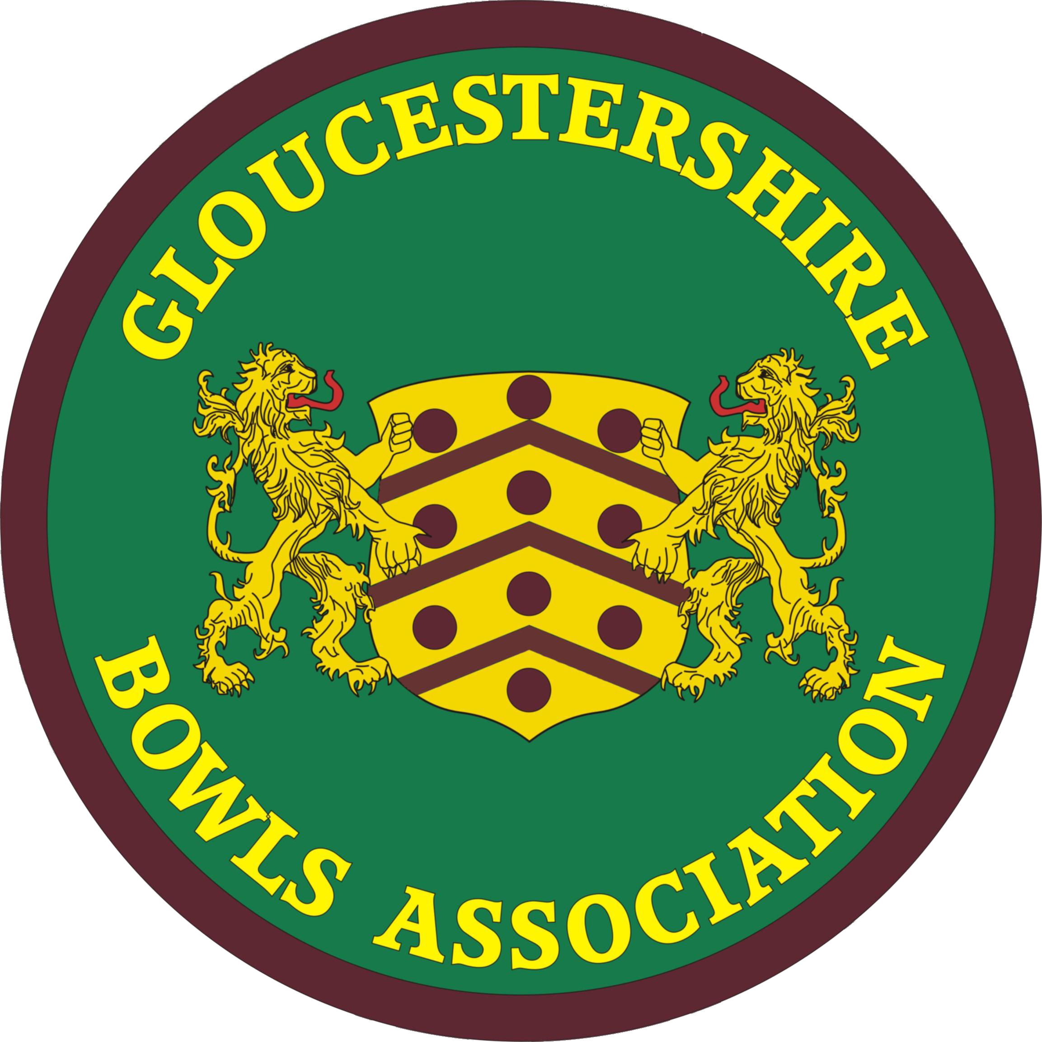 | GLOUCESTERSHIRE BOWLS ASSOCIATION  A Member of Bowls England
G.B.A Joint Executive Committee
Saturday 13 November 2021
Falcon BC : 10.00 am

Participants : Chair and Secretary - Lindsay Collin (County Administrator and WD BE Delegate) LC, Myra Savage (GBA Match Secretary) MS, David Rolls (MD Representative) DR, Roger Harrison (GBA Deputy Match Secretary) RH, Anne Beaven (WD Co-opted Representative) AB, Les Hanley (Deputy County Treasurer) LH, Avril Hole (Deputy County Treasurer) AH, George Thomas (invited) GT, Angela Cary (invited) AC

- Apologies David Skeats (Deputy County Administrator) DS

- Minutes of meetings of 15 September 2021

Agreed as true records. Ratified

- New members of JEC, via Divisions

Shortly, George Thomas as Secretary of the Men’s Division, Angela Cary as Treasurer of the Women’s Division and Val Molton as the fifth, co-opted member from the Women’s Division.

- Joint Executive Committee meeting minutes 15 September 2021

Agreed as a correct record and ratified.

- Matters arising from those minutes

5.1 (Item 10.3) Just to confirm, conclusively, that Minute 12.5, from the ratifed 2 October 2020 JEC minutes, proved LC’s suspicions and refuted DS’s suggestions. The Unified Rules Sub-Committee is the final arbiter on rule changes, though their decisions will be passed through the JEC.
5.2 (Item 10.5) Will come up later, but noted that Bowls England have now decreed that only 1 name per team needs to be submitted per National Championship team event. Ends debate in the GBA.
  - (Item 9) Code of Conduct / Social Media policy

- LH and DS had produced a paper, presented by DR, which was based on the Bowls England model, leavened with their own thoughts. They had also looked at similar Codes of Conduct for Crown Green bowling, Bowls Scotland, English Netball, and others. Most are similar to the BE document, though varying perhaps in relation to social media aspects
- Felt that social media did not need to be separate, as ‘abuse’ covered physical, verbal or social media abuse. Also that smoking was problematic and should simply remain in club rules, rather than be mentioned
- The Committee agreed the draft and asked for it to be circulated, slightly revised according to our conversations. LC asked about whether the GBA itself should have a similar policy, given the number of specifically GBA events, that also being agreed
- The two documents would be updated by DR, and then sent round the clubs by LC, with the recommendation that they produce club policies based on that model. The GBA would advise clubs of the existence of the Association Policy. [Action : LC]
  - (Item 8) 2022 Mixed fixtures RH and MS updated the situation. A mixed game in relation to Barnwood’s centenary had been accepted, on 7 August 2022. The Warwicks mixed game date was liable to be changed, as it fell on a Bank Holiday, but now possibly 1 June 2022.

- Annual Presentation Luncheon LC

6.1 Feedback very favourable from almost everyone. Minor hitch with White Rose team recognition not being acknowledged; apologies offered and rectified on the Web site (though awaiting piece from Graham). [Action : LC]
6.2 Booked for 2022, Sunday 23 October. Deposit paid.

- Financial report LC

  - Current balance £4232, though another payment was authorised yesterday, £196 to the Men’s Division
  - Last year includes 149 new affiliation-paying members from 23 clubs, excluding all new members from the Big Bowls Weekend (for which that number is not yet known), so still 33 clubs to respond since notice on 20 October. Extra income £1341 to date. Will be split as per the main affiliation monies. [Action : LC]
  - Haven’t yet found the time to pass everything that is technically needed for producing the GBA2010 accounts, but am amazed that Maddie (Hale) has effectively completed them, from just the main documents that I sent to her. I just will take the rest of the paperwork across to her, in the near future, so she can clarify a few points for me. There is a surplus for the year of £75.
  - There is one cheque for £270, an affiliation refund cheque from the 2019/20 accounts, which has not been cashed. Must be chased up with the club, but will have to come off next year’s account now. Mixed views on whether this should still be passed to the club concerned, as LC described them as one of the Bristol clubs ‘at risk’.
  - Maddie suggests that we will need a levy again this coming year, after an extraordinary two years of change and costs. Suggest that we return to this in our first meeting next year.
  - Maddie will meet in January with Pat Yates, the incoming County Treasurer, to help her understand what needs to be done.

- GBA Matters

8.1 New GBA club – Churchdown Village BC. Summary of Churchdown responses to all queries on ‘requirements’ circulated. No concerns from Committee. LC to continue dealing with the GBA Affiliation, by notifying the club and also advising the other clubs in the County. [Action : LC]
8.2 New shirts. Three new shirt designs considered, all passed: Churchdown Village, Barnwood and Bristol Arrow. [Action : LC]
8.3 Plenty to be done by the Unified Competition Rules sub-committee. Not been possible to look at a list of possible amendments submitted from all three members of that committee, but must be done by the time that the Yearbooks are produced. A number of Bowls England new requirements to be satisfied. [Action : Sub-Committee]
8.4 GBA Handbooks and Web sites Little time to consider this now. 2022 Handbook and Yearbooks in hand with LC and GT. Web Portal somewhat updated in last week. [Action : LC, GT]

- Bowls England Report

  - New staff structure. Biopics produced and circulated by LC for the members of the committee.
  - Ballots for new BE Director of Competitive Events and Director of Governance. Lengthy discussion on the options, with LC mainly and DR giving views on actual candidates, but all the Committee giving ideas on at what point long-serving Directors might be ‘retired’. In the end, LC left to interpret the steers given by the Committee and complete the voting. [Action : LC]
  - ‘Counties Meeting’ 26/27 November 2021 at Loughborough University. Attendees LC and Ian Gauld. Programme now received. Includes :
- County hot topics discussions
  - National Championships, Competitions and Finals
  - Affiliation and club engagement
  - Bowls England and county relations
- BE update on other key areas
- Full half day on Commonwealth Games 2022 and the opportunities that it presents
  - BE Awards Night
- LC ran through previous situation, with two gender-based Presentation Dinners.
- First inkling, unheralded, was in the National Finals ‘Event Guide’, by which time the decision was taken ! LC not happy about the new awards evening and had already written pithily to BE on the topic.
- LC took the Committee through the various awards. A couple were pre-existing, two or three more have some validity, but some others are gimmicky/contrived. But new ideas could easily be fitted into existing Presentation evenings.
- Concern that the single new Awards Night in fact fails, but - by then – a couple of years of winners have been denied their celebration event and that cannot ever be recaptured.
- LC asked to write to BE and express Gloucestershire’s deep concern about the whole idea and situation, and that the decision be reconsidered. [Action : LC]
  - 2022 National Championships schedule. Now available online and as a PDF.
  - National Championship Competitions and National Competitions
- LC had produced for the Committee a summary document of all the present changes, which she ran through. All of this available online in rather more detail, for anyone particularly interested. On the National Competitions, the use of two ‘regional’ games massively changes the nature of Leamington for competitors in those events, with only 7 games, as against 35 games in 2021 on most of those events. And thus reduces by 80% the possibilities of Gloucester competitors actually qualifying for the Qtr-Final onwards, Leamington rounds.
- Also a discussion on the Inter-County competition format being retained as a knock-out, as against round-robin, it being felt by several people - most notably DR and MS - that the space created in 2022 would allow the round-robin, pre-2021 format, to be resumed. BE would not, however, change this for 2022 now.

- 7th GBA Joint Council Meeting 20 November 2021.

10.1 Matters on the JCM agenda, circulated already:
- Presidential Investitures
- BE changes for 2022 and onwards - information and discussion
- GBA Constitution changes, for discussion [JEC to determine, as per this agenda item, 10]
- ‘Open Forum’, but only for discussion topics pre-warned to the Administrator

  - Proposals originating in Men’s Division, for discussion

In summary :

- Regarding a new sole eligibility criterion for playing in County friendly games
- Regarding ‘nomination’ for selection for County games
- Regarding badging for County games
- Regarding new County shirts
- Regarding a Unified Competition Rule

NB : As the Women’ s Division were denied the opportunity to consider these MD ‘proposals’ in a Delegate Meeting, the WD Management Committee had discussed them at length in their meeting of 1 November and produced a very detailed response to all the proposals. This is far too long a document to be included as part of the minutes, but some key points are summarised below.

Proposal 1 – Eligibility
The following to replace the existing Clause 12.5 on the C & R, as the sole eligibility criterion for playing in County friendly games :
12.5 Clubs may nominate players as eligible to play for the County in friendly games. Clubs should ensure that any player so nominated is of a standard suitable to represent the County; this would normally be someone who regularly represents the club’s senior team in competitive league and cup matches.

- The WD were incredulous that a proposal could be made to delete all the existing eligibility criteria, and implacably opposed to such a damaging and draconian change
- Suggestions made that the assertion that ’clubs are best placed to judge’ the quality of their players in relation to County games is clearly not true, for a host of reasons
- That removing all the objective criteria by which the quality and known performance of players be gauged is unacceptable
- Several members articulated – and exemplified - that handing to club secretaries the right to make (mass) nominations also involved ‘the face doesn’t fit’ situations, besides which some suggestion arose that Section Selectors might not always cast their net wide enough and ignored certain clubs’ players
- That removing the ‘Wild Card’ option, which was expressly introduced to help out the Men’s Division selectors, would be bizarre and counter-productive
- That the suggestion that all clubs necessarily have County-level players in their ‘senior team’ was demonstrably not the case, especially bearing in mind that all players in the ‘senior team’ - regardless of the level of performance and success of that team and the individuals composing it - - would be eligible for the County, was faintly ridiculous
- That even some club secretaries don’t necessarily have any experience or knowledge of County games, on which to base their nominations
- The Women’s Division is fundamentally opposed to a proposal which unavoidably reduces the quality of our County teams
- The Women’s Division were incredulous that they had not even been advised of the ‘proposal’ in advance. So much for unification, equality, reasonableness !

There were other points made, but the key observation is that the Men’s Division Committee members conceded most of these points and also had difficulty with the loss of the Wild Card and the opportunities that that inherently allowed. Resultantly, a vote on the proposal caused a unanimous rejection of the proposal (8-0).
However, it is important to recognise – and this was stressed by the Chair and several other women – that the Men’s Division clearly do have a problem with both poor knowledge and poor perception of the quality requirements for county friendlies. So what is suggested is that :
- this matter is returned to in the future, post-AGM, in an attempt to look for solutions, though the Men’s Division should be doing this too
- clubs are reminded of the fact that past success in club competitions is a route into being nominated for the County. Many secretaries are new and many secretaries are women, so know little of the process
- more imaginative use be made of the Wild Card in relation to maybe young players and players of quality who come close to winning comps but may be ‘blocked’ by the very top players in a club
- in the Men’s Division a campaign this coming year be put in place to try to interest good men players in the County. The Women’s Division do not have these problems to anything like the same degree

Proposal 2 - nominations

12.4 Each club should to provide (sic) their section selector(s) with the names of suitable players as defined in section 12.5 of the Constitution for County games.

This was regarded by the Committee as a now-pointless proposal. Firstly because it was related to Proposal (1), which had just been rejected, but it also that it doesn’t make sense, as the existing Clause 12.4 in the GBA Constitution and Rules (C & R) is about availability, not nomination, and applies only to the Women’s Division, who had originally requested that it be included. Unanimously accepted

Proposal 3 - badging

Badges are awarded for Junior Inter-County competitive games as they are for such seniors. (i)

Flashes should be awarded for all inter-county competitive games. (ii)

Section 11.8 of the Constitution which covers the awarding of flashes and Schedule E and should be reviewed to ensure consistency between them. (iii)

Players who represent the County at the BE National Finals in the National Championships are awarded their County badge but not recorded as County players in the records as this is a listing of those who have played a County game. (iv)

The Women’s Division paper stated that they had no problem with these proposals, in principle. (i) is fine and should always have been the case. Applies to both White Rose and Amy Rose teams
(ii) is basically okay, but noted that a flash should not be given per inter-County competitive game, as stated in the proposal, but only awarded after the requisite number of games have been played in the relevant competition.
(iii) would be accepted.
With (iv), noted that there are slight differences between the MD and WD in relation to their County Lists, so this needed to be factored in
All of these unanimously accepted, but with slight rewording

Proposal 4 – County shirts

A new shirt should be adopted for inter-county competitive games (a County Team shirt). (i)

The JEC investigate the design and adoption of a new County shirt for all games (ii)

The matter of County shirts was already under consideration by the Joint Executive Committee (JEC), and the gist of their existing views (see Minutes of 15 September 2021) was being more precisely restated in the Men’s Division ‘proposals’. But this is also not a constitutional matter, doesn’t need to go to the AGM, rather is an ongoing JEC matter.

In pursuit of this conclusion, and to make quick progress, the Committee felt that matter (i), that of ‘a County Team shirt’ should be placed before an Executive Sub-Committee, charged with looking into the matter in time for the 2022 season. Agreed that LC would give a brief to four people (two from each Division) and ask if they would be prepared to form the Sub-Committee : chosen - Ian Gauld, Graham Phillips, Val Molton, Jacky Howes. [Action : LC; all four people have since agreed]

Proposal 5 – Change in Unified Competition Rules

This proposal not included, as:
- It was recognised that this was also not a constitutional matter, but would be considered by the Unified Competition Rules Sub-Committee [mentioned earlier in (5.1)]
- Just in the very last week, BE had ruled that the only matches in which it would apply would be the Qtr-Final onwards of National Competitions, so the likelihood of it applying to Gloucester competitors was 80% reduced. In fact, last year, all but one competitor complied with the GBA rule, as had been largely the case for many years
- BE is currently looking at updating the Regulations relating to National Competitions, so it was agreed that there is no point making this a big issue for the GBA rules, as there may a change very soon

- Dates of JEC Meetings in 2021/2

Agreed that the following dates would be provisionally put in the diary, but might be susceptible to change if conflicting events or meetings occurred : February 12, April 9, October 15, December 3 [all Saturdays]

- AOB

  - Review of GBA Schedules In particular, Schedule E needs looking at in relation to ‘Proposal 3’ [above], but there are small ways in which some other Schedules have become in need of a minor update to reflect related changes in either our own practices, or due to outside factors. GT offered to look at all the Schedules, as a useful first task and introduction to JEC work as Deputy Administrator, enabling him to also become acquainted with those documents. The GBA C & R might also need a few tweaks, but other priorities have prevented LC from looking at these minor points in time for the 2022 AGM. [Action : LC, GT]

Meeting closed at 1.15 pm

Date of next meeting - Saturday 12 February 2022

Ratified ………………………………………………. Date ………………………………………

